

Service Manual

HP OmniBook 2000, 5500, and 5700

Notice

In a continuing effort to improve the quality of our products, technical and environmental information in this document is subject to change without notice.

Hewlett-Packard makes no warranty of any kind with regard to this material, including, but not limited to, the implied warranties of merchantability and fitness for a particular purpose. Hewlett-Packard shall not be liable for errors contained herein or for incidental or consequential damages in connection with the furnishing, performance, or use of this material.

Hewlett-Packard assumes no responsibility for the use or reliability of its software on equipment that is not furnished by Hewlett-Packard.

As an ENERGY STAR partner, HP has determined that these products meet the ENERGY STAR guidelines for energy efficiency.

All Certifications may not be completed at product introduction. Please check with your HP reseller for certification status.

This equipment is subject to FCC rules. It will comply with the appropriate FCC rules before final delivery to the buyer.

ENERGY STAR is a service mark of the U.S. Environmental Protection Agency. IBM and OS/2 are registered trademarks and TrackPoint is a trademark of International Business Machines Corporation. Pentium and the Intel Inside logo are registered trademarks and MMX is a trademark of Intel Corporation. Photo CD is a registered trademark of Kodak Corporation. Microsoft, MS-DOS, and Windows are registered trademarks, and the Genuine Microsoft Products logo is a trademark of Microsoft Corporation in the United States of America and in other countries. Sound Blaster is a trademark of Creative Technology Ltd.

© Hewlett-Packard Company 1997.

All Rights Reserved. Reproduction, adaptation, or translation without prior written permission is prohibited except as allowed under copyright laws.

Printed in U.S.A.
5965-0262

Table of Contents

List of Figures
List of Tables
Introduction
Product Overview
What’s New
Product Features
Product at a Glance
Product Comparisons
Troubleshooting
Power-On Self-Test
Beep Codes
Display Codes
OmniBook Diagnostics
Running diagnostics
User Interface
Special test hardware requirements
Loop Back Connectors
Details on Individual Diagnostic Tests
Test All
Display - (DISP.COM)
CPU - (CPU.EXE)
RAM - (RAM.COM)
ROM - (ROM.EXE)
PCMCIA - (PCMCIA.COM)
Internal IR - (FIRTEST.EXE)
Full 2 Unit IR Test - (FIRTEST.EXE)
RS-232 Port - (RS232.COM)
Printer Port - (LPT.COM)
Hard Disk - (HDC.EXE)
Floppy Disk - (FDC.EXE)
Battery - (BATTERY.EXE)
Audio - (AUDIO.EXE)
Microphone - (MIKE.EXE)
Joystick - (JOYSTICK.EXE)
Icon LCD - (ICON.EXE)
Keyboard - (KEYBD.EXE)
Pointing Device - (MOUSE.EXE)
CD-ROM - (CDROM.EXE)
SCSI - (SCSI.EXE)
Fan - (FAN.EXE)
Desktop Management Interface (DMI)
Description of DMI
Contents of the DMI Package
System Configuration Utility
Main Configuration Screen
System Menu
Passwords Menu
Disks Menu
Input/Output Menu
Power Menu
Exit Menu
Troubleshooting Tips
Hardware Repair
Battery (End User Replaceable)
Memory (End User Replaceable)
Hard Disk Drive (End User Replaceable)
Floppy Disk Drive (End User Replaceable)
Small Parts (End User Replaceable)
Expansion Door - F1125-60920
Display Contrast/Brightness Slider Button - F1371-60917
Door, Flash BIOS - F1371-60901
Hard Drive Security Cover - F1320-40001
I/O Door - F1350-60910 (OB2000 & OB5700), F1320-60928 (OB5500 only)
Memory Cover - F1320-60927
PCMCIA Button Assembly - F1320-60949
Plastic Feet - F1320-60929
Printer Port Door - F1125-60918
Rubber Feet - F1320-60957
Trackpoint™ Cap - F1320-60971
Display (HP Authorized Service Providers Only)
Display Labels
Keyboard (HP Authorized Service Providers Only)
Icon Board (PCA PB-ICON) (HP Authorized Service Providers Only)
CPU Module (HP Authorized Service Providers Only)
Logic PCA Board (PCA PB-586/IO Bracket) (HP Authorized Service Providers Only)
Programmable Flash BIOS IC (HP Authorized Service Providers Only)
Video Memory (OB2000 & OB5700 Only) (HP Authorized Service Providers Only)
Other Components and Accessories (HP Authorized Service Providers Only)
Appendix A - Technical Specifications
Mass Storage Specifications
Hard Disk Drive
Floppy Disk Drive
CD-ROM Drive
System Resources
System Interrupts
System Memory
System Input/Output Addresses
DMA Channels
Appendix B - Hewlett-Packard Password Removal Policy
Appendix C - Hewlett-Packard TFT Display Quality Statement
Appendix D - Assembly Sub-Component Breakout
Appendix E - Part Numbers

List of Figures

Figure 1 - OmniBook 2000 and 5700 External Features
Figure 2 - OmniBook 2000 and 5700 External Features - continued
Figure 3 - OmniBook 5500 External Features
Figure 4 - OmniBook 5500 External Features - continued
Figure 5 - OmniBook 2000, 5500, and 5700 Center Bay Modules
Figure 6 - OmniBook 2000 and 5700 Exploded Diagram
Figure 7 - OmniBook 5500 Exploded Diagram
Figure 8 - Diagnostics User Interface
Figure 9 - Serial Loop Back Connector
Figure 10 - Parallel Loop Back Connector
Figure 11 - DMI Components
Figure 12 - Main Configuration Screen
Figure 13 - System Menu Screen
Figure 14 - Passwords Menu Screen
Figure 15 - Disks Menu Screen
Figure 16 - Input/Output Menu Screen
Figure 17 - Power Menu Screen
Figure 18 - Exit Menu Screen
Figure 19 - Removing the Battery
Figure 20 - Removing Memory
Figure 21 - Removing the Hard Disk Drive
Figure 22 - Hard Drive Case
Figure 23 - Removing the Hard Drive Plastic Kit
Figure 24 - Removing the Floppy Disk Drive
Figure 25 - Display Screws
Figure 26 - Icon Assembly Removal
Figure 27 - Display Cables
Figure 28 - Display Flex Cable Position
Figure 29 - 10.4" Display Label Placements
Figure 30 - 11.3" Display Label Placements
Figure 31 - 12.1" Display Label Placements
Figure 32 - Palmrest Assembly Removal
Figure 33 - Keyboard Screws
Figure 34 - Keyboard Removal
Figure 35 - Upper Chassis Case Removal
Figure 36 - Icon Board Removal
Figure 37 - CPU and CPU Fan Removal (OB2000 & OB5700 only)
Figure 38 - CPU and Heat Spreader Removal (OB5500 only)
Figure 39 - Additional Screw for Logic PCA Removal
Figure 40 - Keyboard Shielding Plate Removal
Figure 41 - Logic PCA Board Removal
Figure 42 - Flash BIOS Door Removal
Figure 43 - Flash BIOS IC Removal
Figure 44 - Replacing the Flash BIOS IC
Figure 45 - Video Memory Removal

List of Tables

Table 1 - Additional Resources
Table 2 - OmniBook 2000 and 5700 Parts Identification
Table 3 - OmniBook 5500 Parts Identification
Table 4 - POST Beep Codes
Table 5 - POST Display Codes
Table 6 - Dianostic Interface Available Keystrokes
Table 7 - Diagnostic Tests that Require Special Hardware
Table 8 - System Menu Settings
Table 9 - Password Menu Settings
Table 10 - Disks Menu Settings
Table 11 - Input/Output Menu Settings
Table 12 - Power Menu Settings
Table 13 - Exit Menu Settings
Table 14 - OmniBook Troubleshooting Tips
Table 15 - Battery Compatibility Matrix
Table 16 - Memory Compatibility Matrix
Table 17 - Hard Drive Availability Matrix
Table 18 - Display Compatibility Matrix
Table 19 - Display Label Compatibility Matrix
Table 20 - Icon Board Compatibility Matrix
Table 21 - CPU Module Compatibility Matrix
Table 22 - Logic PCA Compatibility Matrix
Table 23 - Other Repairable Components and Accessories
Table 24 - Hard Disk Drive Specifications
Table 25 - Floppy Disk Drive Specifications
Table 26 - CD-ROM Drive Specifications
Table 27 - System Interrupts for the OmniBook 2000 and 5700
Table 28 - System Interrupts for the OmniBook 5500
Table 29 - System Memory Map for the OmniBook 2000 and 5700
Table 30 - System Memory Map for the OmniBook 5500
Table 31 - System I/O Addresses for the OmniBook 2000 and 5700
Table 32 - System I/O Addresses for the OmniBook 5500
Table 33 - DMA Channels for the OmniBook 2000 and 5700
Table 34 - DMA Channels for the OmniBook 5500

Introduction

This document provides reference information for the HP OmniBook 2000, 5500, and 5700. It is intended to be used by HP-qualified service personnel to help with the installation, servicing, and repair of these HP OmniBook PCs.

It is a self-paced guide designed to train you to install, configure, and repair the OmniBook Notebook PC. You can follow it without having any equipment available.

The following table lists additional sources where supplementary information can be obtained.

Table 1 - Additional Resources
Resource | Number/Address | Comments
HP External Web | http://www.hp.com/go/omnibook | No usage restriction  (http://www2.hp.com/go/omnibook provides a European mirror)
HP-MCD Internal Web | http://webmcd.cv.hp.com | Restricted to HP intranet access only
America Online | Keyword: HP | Call (800) 827-6364 for membership within the US
CompuServe | GO HP | Call (800) 524-3388 for membership within the US
HP Bulletin Board Service | (208) 344-1691 (US only) | Refer to the latest Product Support Plan for non-US BBS numbers
HP First (automated fax) | - 333-1917 | US and Canada
 | (801) 344-4809 | Outside US and Canada
 | (800) 544-9976 | Reseller support number (enter outlet id number)
HP Support Assist CD-ROM | (800) 457-1762 | US and Canada
 | (801) 431-1587 | Outside US and Canada
HP MCD Service Engineer | svc-eng_mcd@om.cv.hp.com | Email address for service related questions and issues

Part 1

Product Overview
- What’s New
- Product Features
- Product at a Glance
- Product Comparisons

What’s New

The OmniBook 2000 is the newest OmniBook in the Desktop-to-Go Notebook PC series. It has many of the same features as the OmniBook 5700 while still maintaining a lower price. The following list compares and contrasts the OmniBook 2000 and OmniBook 5700.

Feature | OmniBook 2000 | OmniBook 5700
Processor | 133-MHz Intel Pentium® with and without MMX™ technology | Intel Pentium® P55C  150 MHz and 166 MHz with MMX™ technology
Cache | no L2 cache  16-KB or 32-KB L1 cache | 512-KB L2 pipeline-burst synchronous cache  32-KB L1 cache
Memory | expandable to 128MB | expandable to 128MB
Display | 12.1” TFT SVGA up to 16.7M colors 12.1” DSTN SVGA up to 64K colors | 12.1” TFT XGA and 12.1” TFT SVGA up to 16.7M colors
Video | C&T 65554 64-bit accelerated graphics processor with 2M video RAM and Zoom Video enabled | C&T 65554 64-bit accelerated graphics processor with 2M video RAM and Zoom Video enabled
PC Card | Cardbus support | Cardbus support
System Chipset | Opti Viper-N+ | Opti Viper-N+
Desktop Management Interface | Pre-installed DMI 1.1 software | Pre-installed DMI 1.1 software
Advanced Power Management | APM 1.2 | APM 1.2
Off States | On, suspend, resume, hibernate and full off | On, suspend, resume, hibernate and full off

Product Features

The first two illustrations (Figure 1 and Figure 2) point out the key external features of the OmniBook 2000 and 5700. The second two illustrations (Figure 3 and Figure 4) point out the key external features of the OmniBook 5500. Figure 5 on page 11 shows the accessories that can be used in the center bay of the OmniBook 2000, 5500, and 5700.

Display control(s)
Microphone
On/Suspend button
Kensington lock
Audio jacks
PC card slots
Battery
Floppy drive (center bay accessory slot)
Hard drive
Speaker
Speaker
Status panel
Pointing device
Latch
Latch
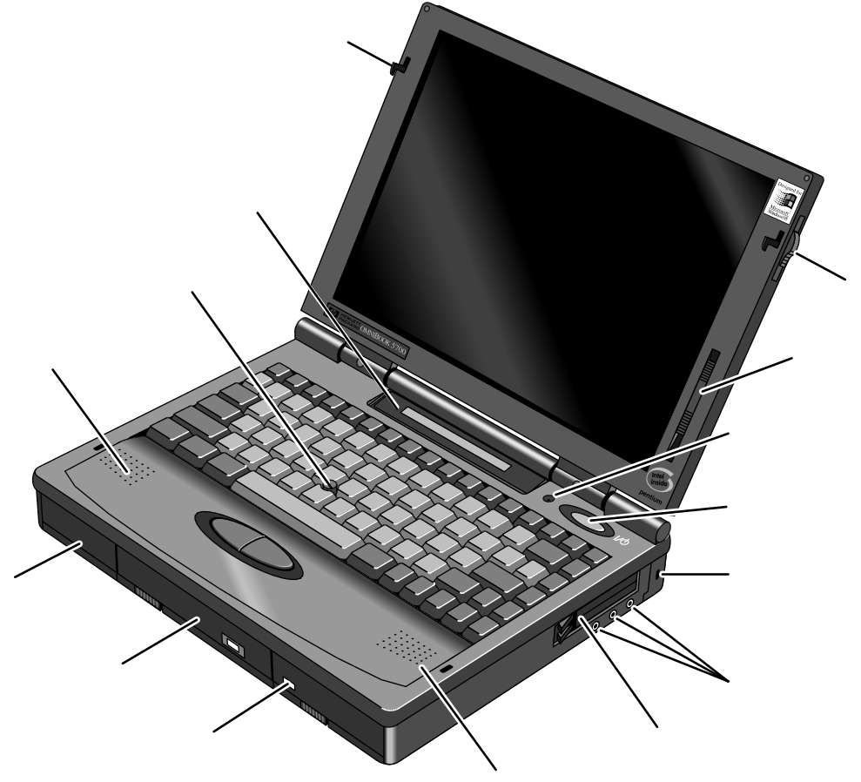

Figure 1 - OmniBook 2000 and 5700 External Features

Kensington lock
Kensington lock
MIDI/Joystick port
IR port
VGA out
AC adapter
Off button
Parallel port
Reset button
Tilt foot
Docking port
Serial port
Mouse or Keyboard

Figure 2 - OmniBook 2000 and 5700 External Features - continued

Display control
On/Suspend/Off button
Kensington lock
Audio jacks
PC card slots
Speaker
Battery
Floppy drive (center bay accessory slot)
Hard drive
Speaker
Pointing device
Microphone
Status panel
Latch
Latch
Figure 3 - OmniBook 5500 External Features

Serial port
Video out
VHS out
VGA out
Kensington lock
AC adapter
Parallel port
Reset button
Tilt foot
Docking port
Mouse or Keyboard
Kensington lock
IR port
MIDI/Joystick port
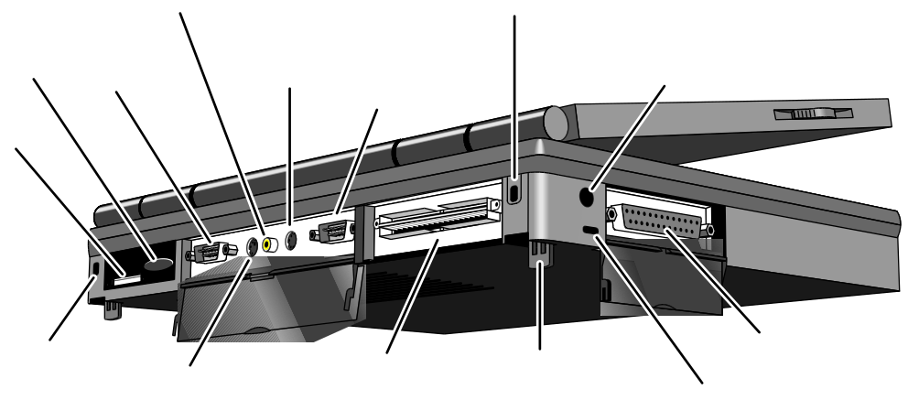

Figure 4 - OmniBook 5500 External Features - continued

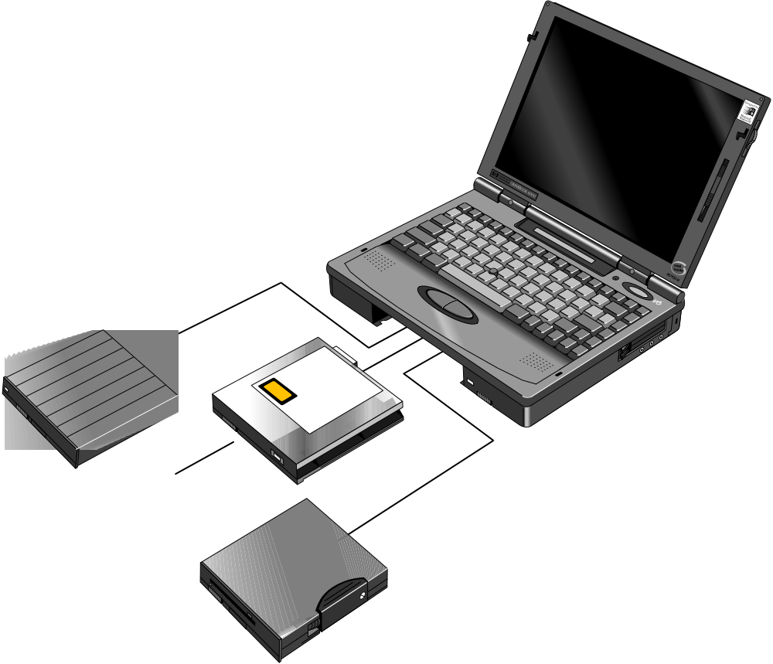
Figure 5 - OmniBook 2000, 5500, and 5700 Center Bay Modules
CD-ROM drive
High-capacity battery
Floppy disk drive

Product at a Glance

Figure 6 - OmniBook 2000 and 5700 Exploded Diagram

Table 2 - OmniBook 2000 and 5700 Parts Identification
 | Description | Part Number | Exchange Part # | User Replace. | OB5700 | OB2000
1 | Memory Module
 | 8MB RAM | F1134-60901 | F1134-69001 | Y | ü | ü
 | 16MB RAM | F1135-60901 | F1135-69001 | Y | ü | ü
 | 32MB RAM | F1136-60901 | F1136-69001 | Y | ü | ü
 | 64MB RAM | F1335-60901 | F1335-69001 | Y | ü | ü
2 | Bezel | F1320-60958 |  | N | ü | ü
3 | Card Bus Bracket | F1350-60916 |  | N | ü | ü
4 | CPU Fan | F1350-60906 |  | N | ü | ü
5 | CPU Module
 | CPU Module/150C | F1350-60904 | F1350-69004 | N | ü
 | CPU Module/166C | F1350-60905 | F1350-69005 | N | ü
 | CPU Module/P54C-133 | F1371-60908 | F1371-69008 | N |  | ü
 | CPU Module/P55C-133 (MMX) | F1371-60909 | F1371-69009 | N |  | ü
6 | Dock Grounding Spring Plate | F1320-60962 |  | N | ü | ü
7 | Door, Flash BIOS | F1371-60901 |  | Y |  | ü
8 | EMI Spring for LCD Hinge | F1350-60913 |  | N | ü | ü
9 | Expansion Door | F1125-60920 |  | Y | ü | ü
10 | FFC Cable T/B to M/B 10 PIN | F1320-60950 |  | N | ü | ü
11 | 3.5" floppy disk drive | F1195-60901 |  | Y | ü | ü
12 | HDD-FPC Flex | F1320-60961 |  | N | ü | ü
13 | Hard Disk Drive
 | HDD Drive 1.44GB | F1375-60901 | F1375-69001 | Y |  | ü
 | HDD Drive 2.0GB | F1339-60901 | F1339-69001 | Y | ü | ü
 | HDD Drive 3.0GB | F1348-60901 | F1348-69001 | Y | ü
14 | HDD PCB Bracket | F1320-60965 |  | N | ü | ü
15 | HDD Plastic Kit | F1350-60920 |  | Y | ü | ü
16 | HDD Security Cover | F1320-40001 |  | Y | ü | ü
17 | Icon Assembly | F1320-60918 |  | N | ü | ü
18 | I/O Bracket Grounding Clip | F1350-60912 |  | N | ü | ü
19 | I/O Door | F1350-60910 |  | Y | ü | ü
20 | IR Lens | F1320-60952 |  | N | ü | ü
21 | KBD Shielding Plate | F1320-60960 |  | N | ü | ü
22 | Keyboard | * |  | N | ü | ü
23 | LCD Display
 | LCD Assy 12.1 TFT/X | F1350-69002 | F1350-69002 | N | ü
 | LCD Assy/SMG 12.1 TFT/S | F1320-69094 | F1320-69094 | N | ü | ü
 | LCD Assy-12.1" DSTN | F1371-60906 | F1371-69006 | N |  | ü
24 | Lower Chassis Case
 | Lower Chassis Case - 5700 | F1350-60914 |  | N | ü
 | Lower Chassis Case - 2000 | F1371-60905 |  | N |  | ü
25 | Memory Cover Door | F1320-60927 |  | Y | ü | ü
26 | Microphone Assembly | F1081-60946 |  | N | ü | ü
27 | Palmrest2 Assembly | F1320-60986 |  | N | ü | ü
28 | PCA - DC Power Supply | F1350-60909 |  | N | ü | ü
29 | PCA PB-586/IO Bracket | F1350-60901 | F1350-69001 | N | ü | ü
30 | PCA PB-Icon Board
 | PCA PB-ICON/SVGA | F1350-60907 |  | N | ü | ü
 | PCA PB-ICON/XGA | F1350-60908 |  | N | ü
 | PCA PB-ICON/DSTN | F1371-60911 |  | N |  | ü
31 | PCMCIA Button Assembly | F1320-60949 |  | Y | ü | ü
32 | Plastic Foot | F1320-60929 |  | Y | ü | ü
33 | Printer Port Door | F1125-60918 |  | Y | ü | ü
34 | Prog Flash IC, BIOS | F1371-60903 |  | N | ü | ü
35 | Rubber Foot | F1320-60957 |  | Y | ü | ü
36 | Screw - BIOS Door | F1371-60902 |  | Y |  | ü
37 | Screw - CPU M2 X 4L | F1320-60963 |  | N | ü | ü
38 | Screw - CPU M2.6 X 6L | F1081-60942 |  | N | ü | ü
39 | Screw - FTB M2.6x10L | F1350-60925 |  | N | ü | ü
40 | Screw - FTB M2.6x8L | F1350-60926 |  | N | ü | ü
41 | Screw - HDD Door | F1320-60919 |  | Y | ü | ü
42 | Screw - ISOF M2.6x6L | F1350-60923 |  | N | ü | ü
43 | Screw - ISOP M2x6L Nyl | F1350-60924 |  | N | ü | ü
44 | Screw - ISOP M2.6X8L NYLOK | F1081-60939 |  | N | ü | ü
45 | Screw - ISOT M2.6x4L | F1350-60927 |  | N | ü | ü
46 | Screw - Keyboard | F1320-60920 |  | N | ü | ü
47 | Standoff-M2x11.75 Nyl | F1350-60928 |  | N | ü | ü
48 | Standoff-M2x15L Nyl | F1350-60929 |  | N | ü | ü
49 | Std Li-Ion Battery | F1193-60902 |  | Y | ü | ü
50 | Sub Batt - NiMHd | F1350-60921 |  | N | ü | ü
51 | Upper Chassis Case | F1350-60915 |  | N | ü | ü
52 | Video RAM | F1350-60922 |  | N | ü | ü
Note, this is a partial parts list. For a complete parts list, please refer to Appendix E or the Product Support Plan.
*For a complete listing of available localized keyboards, refer to Appendix E or the Product Support Plan.

Figure 7 - OmniBook 5500 Exploded Diagram

Table 3 - OmniBook 5500 Parts Identification
 | Description | Part Number | Exchange Part # | User Replace.
1 | Bezel | F1320-60958 |  | N
2 | CPU Module
 | CPU Module/100C | F1320-60901 | F1320-69001 | N
 | CPU Module/120C | F1320-60902 | F1320-69002 | N
 | CPU Module/133C | F1320-60903 | F1320-69003 | N
3 | Dock Grounding Spring Plate | F1320-60962 |  | N
4 | Expansion Door | F1125-60920 |  | Y
5 | FFC Cable T/B to M/B 10 PIN | F1320-60950 |  | N
6 | 3.5" floppy disk drive | F1195-60901 |  | Y
7 | HDD-FPC Flex | F1320-60961 |  | N
8 | Hard Disk Drive
 | HDD Drive 810MB | F1191-60901 | F1191-69001 | Y
 | HDD Drive 1.35GB | F1192-60901 | F1192-69001 | Y
 | HDD Drive 2.0GB | F1339-60901 | F1339-69001 | Y
9 | HDD PCB Bracket | F1320-60965 |  | N
10 | HDD Plastic Kit | F1320-60947 |  | Y
11 | HDD Security Cover | F1320-40001 |  | Y
12 | Heat Pipe | F1320-60964 |  | N
13 | Heat Pipe Bracket | F1320-60972 |  | N
14 | Heat Pipe Spreader | F1320-60921 |  | N
15 | Heat Sink | F1320-60954 |  | N
16 | Icon Assembly | F1320-60918 |  | N
17 | I/O Bracket Grounding Clip | F1350-60912 |  | N
18 | I/O Door | F1320-60928 |  | Y
19 | IR Lens | F1320-60952 |  | N
20 | KBD Shielding Plate | F1320-60960 |  | N
21 | Keyboard | * |  | N
22 | LCD Display
 | LCD Assy 10.4” TST/S | F1320-60904 | F1320-69004 | N
 | LCD Assy 11.3” DSTN/S | F1320-60905 | F1320-69005 | N
 | LCD Assy 12.1" TFT/S | F1320-60906 | F1320-69006 | N
 | LCD Assy-SMG 12.1" TFT/S | F1320-60994 | F1320-69094 | N
23 | Lower Chassis Case | F1320-60930 |  | N
24 | Memory Cover Door | F1320-60927 |  | Y
25 | Memory Module
 | 8MB RAM | F1134-60901 | F1134-69001 | Y
 | 16MB RAM | F1135-60901 | F1135-69001 | Y
 | 32MB RAM | F1136-60901 | F1136-69001 | Y
26 | Microphone Assembly | F1081-60946 |  | N
27 | Palmrest2 Assembly | F1320-60986 |  | N
28 | PCA - DC Power Supply | F1320-60925 |  | N
29 | PCA PB-586/IO Bracket | F1320-60926 | F1320-69026 | N
30 | PCA PB-Icon Board
 | PCA PB-ICON | F1320-60924 |  | N
 | PCA PB-ICON/SMG | F1320-60993 |  | N
31 | PCMCIA Button Assembly | F1320-60949 |  | Y
32 | Plastic Foot | F1320-60929 |  | Y
33 | Printer Port Door | F1125-60918 |  | Y
34 | Prog Flash IC, BIOS | F1321-60907 |  | N
35 | Rubber Foot | F1320-60957 |  | Y
36 | Screw - CPU M2 X 4L | F1320-60963 |  | N
37 | Screw - CPU M2.6 X 6L | F1081-60942 |  | N
38 | Screw - HDD Door | F1320-60919 |  | Y
39 | Screw - ISOP M2.0x6.0L Nylok | F1350-60924 |  | N
40 | Screw - ISOP M2.6X8L Nylok | F1081-60939 |  | N
41 | Screw - M2.6x4.0L | F1350-60927 |  | N
42 | Screw - Keyboard | F1320-60920 |  | N
43 | Standoff-M2x11.75 Nyl | F1320-60951 |  | N
44 | Standoff-M2x15L Nyl | F1320-60955 |  | N
45 | Std Li-Ion Battery | F1193-60902 |  | Y
46 | Sub Battery 4.8v | F1081-60925 |  | N
47 | Upper Chassis Case | F1320-60931 |  | N
Note, this is a partial parts list. For a complete parts list, please refer to Appendix E or the Product Support Plan.
*For a complete listing of available localized keyboards, refer to Appendix E or the Product Support Plan.

Product Comparisons

 | HP OmniBook 5700 | HP OmniBook 5500 | HP OmniBook 2000
Size Closed | 29.5 x 22.6 x 4.9 cm  (11.6 x 8.9 x 1.93 in) | 29.5 x 22.6 x 4.9 cm  (11.6 x 8.9 x 1.93 in) | 29.5 x 22.6 x 4.9 cm  (11.6 x 8.9 x 1.93 in)
Weight | 3.27 kg (7.2 lb) | 3.4 kg (7.5 lb) | 3.27 kg (7.2 lb)
Processor | 166- or 150-MHz Intel Pentium® with MMX technology | 100-, 120-, or 133-MHz Intel Pentium processor | 133-MHz Intel Pentium with and without MMX technology
Bus Architecture | 32-bit PCI bus | 32-bit PCI bus | 32-bit PCI bus
Cache | 512-KB burst-synchronous L2 cache | 256-KB external L2 cache | no L2 cache
Display Size | 12.1-inch TFT | 10.4- or 12.1-inch diagonal TFT  11.3-inch diagonal DSTN | 12.1-inch diagonal TFT  12.1-inch diagonal DSTN
Display Resolution | XGA TFT 1024 x 768 x 64k colors  SVGA TFT 800 x 600 x 16.7M colors | SVGA TFT 800 x 600 x 64K colors  SVGA DSTN 800 X 600 X 256 colors | SVGA TFT 800 x 600 x 16.7M colors  SVGA DSTN 800 x 600 x 64K colors
Video Bus | PCI local bus video | PCI local bus video | PCI local bus video
Video RAM | 2-MB video RAM | 1-MB video RAM | 2-MB video RAM
VGA-out Support | XGA-out supports up to 1024 x 768 x 64k colors | XGA-out supports up to 1024 x 768 x 256 colors | XGA-out supports up to 1024 x 768 x 64k colors
Video Controller | Chips and Technology 65554 controller (64-bit) | Chips and Technology 65548 controller (32-bit) | Chips and Technology 65554 controller (64-bit)
Power | AC adapter 100 to 240 Vac (50 to 60 Hz) input; 12 Vdc, 3.3 A output | AC adapter 100 to 240 Vac (50 to 60 Hz) input; 12 Vdc, 3.3 A output | AC adapter 100 to 240 Vac (50 to 60 Hz) input; 12 Vdc, 3.3 A output
Battery Type | 14.4-Vdc, 2.5-AH rechargeable Lithium-Ion battery  Optional, 14.4-Vdc, 3.75-AH enhanced Lithium Ion battery | 14.4-Vdc, 2.5-AH rechargeable Lithium-Ion battery  Optional, 14.4-Vdc, 3.75-AH enhanced Lithium Ion battery | 14.4-Vdc, 2.5-AH rechargeable Lithium-Ion battery  Optional, 14.4-Vdc, 3.75-AH enhanced Lithium Ion battery
Battery Life | Up to 2.5 hours with one LiIon battery (enhanced LiIon battery adds up to 3.75 hours) | Up to 2.5 hours with one LiIon battery (enhanced LiIon battery adds up to 3.75 hours) | Up to 2.5 hours with one LiIon battery (enhanced LiIon battery adds up to 3.75 hours)
Recharge Rate | Battery recharges to high level in 4 hours using AC adapter while PC is on or off | Battery recharges to high level in 4 hours using AC adapter while PC is on or off | Battery recharges to high level in 4 hours using AC adapter while PC is on or off
Advanced Power Management | Instant-on maintains computer in ready-to-work state for weeks on a full charge; returns you to your application or file instantly  2-minute low-battery warning | Instant-on maintains computer in ready-to-work state for weeks on a full charge; returns you to your application or file instantly  2-minute low-battery warning | Instant-on maintains computer in ready-to-work state for weeks on a full charge; returns you to your application or file instantly  2-minute low-battery warning
Removable Modules | - Floppy disk drive internal/external (can be replaced with a second battery or CD ROM drive)  - Hard disk drive  - RAM  - Battery | - Floppy disk drive internal/external (can be replaced with a second battery or CD ROM drive)  - Hard disk drive  - RAM  - Battery | - Floppy disk drive internal/external (can be replaced with a second battery or CD ROM drive)  - Hard disk drive  - RAM  - Battery
- Hard Disk Drive | 3.0-billion-byte or 2.0-billion-byte hard drives | 810-MB, 1.35-GB, or 2.0GB hard disks | 1.44-billion-byte or 2.0-billion-byte hard drives
Floppy Disk Drive | Internal 3.5-inch, 1.44-MB, standard; swaps with CD-ROM or enhanced battery; usable externally | Internal 3.5-inch, 1.44-MB, standard; swaps with CD-ROM or enhanced battery; usable externally | Internal 3.5-inch, 1.44-MB, standard; swaps with CD-ROM or enhanced battery; usable externally
CD-ROM Drive | Optional, internal, 10x | Optional, internal, 10x | Optional, internal, 10x
Memory | Self-refreshed FPM DRAM  16 or 32-MB models, expandable to 128 MB  8-, 16-, 32-, and 64-MB RAM modules available | Self-refreshed FPM DRAM  8 or 16-MB models, expandable to 64 MB  8-, 16-, and 32-MB RAM modules available | Self-refreshed FPM DRAM  16 or 32-MB models, expandable to 128 MB  8-, 16-, 32-, and 64-MB RAM modules available
Audio | 16-bit with Sound Blaster™ Pro and MIDI support  Stereo sound via two built-in speakers | 16-bit with Sound Blaster Pro compatible and MIDI support  Stereo sound via two built-in speakers | 16-bit with Sound Blaster Pro and MIDI support  Stereo sound via two built-in speakers
IO Ports | - 9-pin, 115,200-bps, RS-232 port  - 25-pin bidirectional ECP/EPP parallel port  - XGA-out (up to 1024 x 768 x 64K)  - Fast-IR-IRDA compliant @ 4Mbps  - Expansion bus connector  - PS/2 keyboard/mouse port  - Headphone/stereo-out port  - Stereo-in and microphone ports  - MIDI/joystick port | - 9-pin, 115,200 - b/s, RS-232 port  - 25-pin bidirectional ECP/EPP parallel port  - XGA-out (up to 1024 x 768 x 256)  - Fast-IR-IRDA compliant @ 4Mbps  - Expansion bus connector  - NTSC/PAL video-out port (RCA and SVideo)  - PS/2 keyboard/mouse port  - Headphone/stereo-out port  - Stereo-in and microphone ports  - MIDI/joystick port | - 9-pin, 115,200-bps, RS-232 port  - 25-pin bidirectional ECP/EPP parallel port  - XGA-out (up to 1024 x 768 x 64K)  - Fast-IR-IRDA compliant @ 4Mbps  - Expansion bus connector  - PS/2 keyboard/mouse port  - Headphone/stereo-out port  - Stereo-in and microphone ports  - MIDI/joystick port
- PCMCIA | One Type III PCMCIA slot (or use as two Type II slots) with 3.3-V or 5-V support  Zoomed video support for lower slot  CardBus support (both slots) | One Type III PCMCIA slot (or use as two Type II slots) with 3.3-V or 5-V support. | One Type III PCMCIA slot (or use as two Type II slots) with 3.3-V or 5-V support  Zoomed video support for lower slot  CardBus support (both slots)
Docking | Optional docking system with one PCI/ISA and one ISA slot, parallel, serial, XGA-out (up to 1024 x 768 x 64k), keyboard, PS/2 mouse, MIDI/joystick, audio and SCSI-2 ports.  Optional port replicator with parallel, serial, video-out, keyboard, PS/2 mouse, MIDI/joystick, and audio ports | Optional docking system with one PCI/ISA-and one ISA slot, parallel, serial, XGA-out (up to 1024 x 768 x 256), keyboard, PS/2 mouse, MIDI/joystick, audio and SCSI-2 ports. | Optional docking system with one PCI/ISA-and one ISA slot, parallel, serial, XGA-out (up to 1024 x 768 x 64K), keyboard, PS/2 mouse, MIDI/joystick, audio, and SCSI-2 ports.  Optional port replicator with parallel, serial, video-out, keyboard, PS/2 mouse, MIDI/joystick, and audio ports.
Pre-installed Software | Microsoft® Windows® for Workgroups 3.11 and MS-DOS® 6.22 co-loaded with Microsoft Windows 95*  Windows 95-compatible Plug and Play BIOS  Advanced Power Management 1.2  DMI 1.1 under Windows 95 with TopTools  HP PIM and Financial Calculator  On-line documentation | Microsoft Windows for Workgroups 3.11 and MS-DOS 6.22 co-loaded with Microsoft Windows 95*  Windows 95-compatible Plug and Play BIOS  Advanced Power Management 1.1  HP PIM and Financial Calculator  On-line documentation | Microsoft® Windows® for Workgroups 3.11 and MS-DOS® 6.22 co-loaded with Microsoft Windows 95*  Windows 95-compatible Plug and Play BIOS  Advanced Power Management 1.2  DMI 1.1 under Windows 95 with TopTools  HP PIM and Financial Calculator  On-line documentation
Security Features | - 2-level password protection  - Hardware-based hard drive password  - Electronic serial number in CMOS accessible through DMI  - PC ID (tattooing)  - Kensington lock slots | - 2-level password protection  - PC ID (tattooing) and serialization  - Drive lock  - Kensington lock slots | - 2-level password protection  - Hardware-based hard drive password  - Electronic serial number in CMOS accessible through DMI  - PC ID (tattooing)  - Kensington lock slots
- Warranty | 3-year return-to HP for repair (1-year on battery and accessories) | 3-year return-to-HP for repair for premium models; 1-year return-to-HP for VL's (1-year on battery and accessories) | 3-year return-to HP for repair (1-year on battery and accessories)
*(Note: Upon first boot, the end user must make a ONE-TIME selection between Windows 95 and Windows for Workgroups. Later, if the end user desires the rejected operating system, the end user will need to acquire and pay for such product as a separate transaction.)

Part 2

Troubleshooting
- Power-On Self-Test
- OmniBook Diagnostics
- Desktop Management Interface
- System Configuration Utility
- Troubleshooting Tips

Power-On Self-Test

The OmniBook 2000, 5500, and 5700 BIOS includes a Power-On Self-Test (POST) facility that tests a number of hardware and firmware items in the unit at each cold-start (BOOT or RESET).

The OmniBook self-test alone should not be used to diagnose a hardware problem. If the self-test results are absolutely clear and repeatable, confirm the results with at least two other non-self-test troubleshooting tools.

Within POST, there are three kinds of messages:
- Error Messages – These messages appear when there is a failure in hardware, software, or firmware.
- Informational Messages – These messages provide information to the user but require no action.
- Beep Codes – This kind of warning sounds when POST errors occur and the screen is not yet available.

Beep Codes

These multiple beep codes indicate a failure in a simple test of:
- a portion of base memory
- flash BIOS checksum
- a portion of conventional memory
- a portion of extended memory

If the unit fails to boot
- all accessories are removed, including:
memory, floppy drive, docking station, modems and other PC Cards, printers, external displays, pointing devices, and keyboard
- clean AC power is provided (no "chained" battery chargers or auto adapters), and press reset.
If the unit still fails to boot, it requires service.

Beep codes are used to identify a POST error that occurs when the screen is not available. Once the screen is operating, diagnostic messages are reported to the screen. There are beep codes for both fatal and nonfatal system board errors.

Table 4 - POST Beep Codes
Beep Code | Description
S-S-S-P-S-S-L-P | The DMA page registers are faulty.
S-S-S-P-S-L-S-P | The refresh circuitry is faulty
S-S-S-P-S-L-L-P | The ROM checksum is incorrect
S-S-S-P-L-S-S-P | The CMOS RAM test failed
S-S-S-P-L-S-L-P | The DMA controller is faulty
S-S-S-P-L-L-S-P | The interrupt controller failed
S-S-S-P-L-L-L-P | The 8042 keyboard controller failed
S-S-L-P-S-S-S-P | No video adapter was found
S-S-L-P-S-S-L-P | No RAM installed. No message is displayed.

Display Codes

There are a number of Power On Self Test (POST) tests that are performed after the Beep Code tests. Failure of one or more of these tests will result in a displayed failure code (such as 03044). It is extremely important not to interpret a failure code immediately as a hardware failure. The failure should be confirmed with a clean boot. A clean boot is defined as pressing the reset button after removing all accessories (including memory, floppy drive, modems, PC cards, and printers) and providing a reliable power source. Note, make sure the display is adjusted to be visible.

Table 5 - POST Display Codes
Message | Possible Cause
CLOCK NOT TICKING CORRECTLY | The real time clock is not ticking.
COLOR/MONO SWITCH INCORRECT | The COLOR/MONO switch on the system board is incorrect for the installed hardware.
CMOS CHECKSUM INVALID - RUN SCU | CMOS RAM information has been corrupted and needs to be reinitialized via the System Configuration Utility.
CMOS FAILURE - RUN SCU | CMOS RAM has lost power and needs to be reinitialized via the System Configuration Utility.
FLOPPY CONTROLLER FAILED | The floppy controller failed to respond to the reset command. Power down the system and check all appropriate connections. It the floppy controller continues to fail, you may need to replace it.
FLOPPY DISK TRACK 0 FAILED | The floppy drive cannot read track 0 of the floppy disk in the drive. Try another diskette. If the problem persists, you may need to replace the floppy drive.
FLOPPY INFORMATION INVALID - RUN SCU | The drive parameters stored in CMOS do not match the floppy drives detected in the system.
HARD DISK CONTROLLER ERROR | The hard disk controller failed to respond to the reset command. Possible solutions: 1) Check the drive parameters. 2) Power down the system and check all appropriate connections. If the problem persists, you may need to replace the hard disk controller.
HARDWARE INFO DOES NOT MATCH VIDEO CARD - RUN SCU | The video adapter type specified in CMOS RAM does not match the installed hardware.
KEYBOARD CONTROLLER FAILURE | The keyboard failed the self-test command. Check to see if the keyboard controller is properly installed. If the problem continues, replace the controller.
KEYBOARD FAILURE | The keyboard failed to respond to the RESET ID Command.
MACHINE IS LOCKED - TURN KEY | The system will not continue the boot sequence until you insert the key into the key lock and turn it.
NO BOOTABLE FLOPPY DRIVE 0 INSTALLED | No bootable floppy drive was detected. Possible solutions: 1) Power down the system and check all appropriate connections, cables, etc. 2) In configurations where no floppy drive is installed, run System Configuration Utility and make sure the diskette drive configuration item is set to "None". 3) Replace the diskette drive if necessary.
NO INTERRUPTS FROM TIMER 0 | The periodic timer interrupt is not occurring.
RAM PARITY ERROR AT LOCATION xxxx | A RAM parity error occurred at the specified (hexadecimal) location.
ROM AT xxxx (LENGTH YYYY) WITH NON-ZERO CHECKSUM (zz) | An illegal adapter ROM was located at the specified address. An external adapter (such as a video card) may be causing a conflict.
TIME/DATE CORRUPT - RUN SCU | The time and date stored in the real time clock have been corrupted, possibly by a power loss.
UNEXPECTED AMOUNT OF MEMORY - RUN SCU | The amount of memory detected by POST does not match the amount specified in CMOS RAM.
CMOS RAM TEST FAILED | A walking built test of CMOS RAM locations 0E (Hex) - 3F (Hex) failed.
DMA CONTROLLER FAULTY | A sequential read/write of the transfer count and transfer address registers within the primary and secondary DMA controllers failed.
FAULTY DMA PAGE REGISTERS | A walking bit read/write of the 16 DMA controller page registers starting at location 80 Hex failed.
FAULTY REFRESH CIRCUIT | A continuous read/write test of port 61h found that bit 4 (Refresh Detect) failed to toggle within an allotted amount of time.
INTERRUPT CONTROLLER FAILED | A sequential read/write of various Interrupt Controller registers failed.
ROM CHECKSUM INCORRECT | A checksum of the ROM BIOS does not match the byte value at F000:FFFF.

OmniBook Diagnostics

The OmniBook diagnostics program provides a tool for diagnosing and isolating a hardware problem. The diagnostics software is intended for use in concert with additional troubleshooting methods to accurately determine the cause of trouble. The diagnostics program is not designed for unassisted customer use. Unless otherwise indicated, all diagnostic tests and features are available on the OmniBook 2000, 5500, and 5700.

All tests provided in the diagnostics program are designed to run following a clean boot of the OmniBook. This ensures that the environment of the computer will be In a dependable state for the diagnostics program to properly test the hardware components. The individual tests are non-destructive and are intended to preserve the state of the OmniBook. Reboot after completion of any test to ensure proper loading of necessary drivers.

Running diagnostics

The diagnostic software must be executed from a DOS command-line following a clean boot. For a system that normally boots to Windows for Workgroups, press F5 at bootup after the BIOS displays the CPU speed. This will boot the OmniBook to a DOS command-line. For a Windows 95 system, press Shift-F5. The user interface may be invoked or individual tests can be initiated from the command-line. When executed from the command-line, a test may or may not display results, but always terminates with either a zero for success or a non-zero for failure (the DOS errorlevel will be set accordingly). Non-zero results can be unique for each test (a result of 2 from a RAM test has a different meaning than a 2 from the serial test).

The diagnostic program is located in the c:\omnibook\diag directory. The main diagnostic program (user interface) is invoked by typing diag at the command-line. The main program looks for executables to perform individual tests using the same path with which it was invoked. For example, if the program was initiated by typing c:\omnibook\diag\diag from the root directory, then the diag directory will be searched for individual test programs.

Logging Test Results
Results can be logged to a file in the current drive and directory by pressing Alt-L. Only failures are written to the file. The log file is in ASCII format with the following layout:

date | time | test label | failure description

The main program performs the logging. When logging is enabled for the first time (via the keyboard), the specified file is opened. If the file already exists, it is truncated. When logging is disabled or the program is terminated, the file is closed.

Looping Tests
Any test, or selection of tests, can be made to repeat or loop. The loop count can be changed by pressing Alt-C. The default count is 1; the maximum count is 9,999. A count of zero (0) indicates infinite looping. The count that is set applies to all tests until DIAG is terminated or the count is changed again.

Pressing the Backspace key will abort the looping sequence. The diagnostics program will check the keyboard for the Backspace key between each test and each iteration. However, since many tests also read the keyboard and discard unexpected key presses, this feature may not work as expected.

When looping is enabled (count 0 or greater than 1), the date and time is displayed as each test is executed. The timestamp is displayed as the test begins and is over-written at completion.

The DIAG.INI file, located in the c:\omnibook\diag directory, contains a “Loop” entry for each test. The value of the entry determines whether the test can be placed in looping mode as part of a group of tests. A value of “1” enables looping in a group, while a ”0” disables this feature. Regardless of this setting, looping will always be available when a test is initiated individually; the Loop entry in DIAG.INI only affects looping on groups of test. In general, group looping is disabled for the tests that require action by the tester such as the keyboard, mouse, and joystick tests.

User Interface

The main diagnostic program provides a user interface where the following actions can be performed:
- launch individual or groups of tests
- loop through a given set of tests n times or indefinitely
- optionally log failures to disk

An example of the user interface screen is displayed below. Note, on the OmniBook 5500, the Full 2 Unit IR and Fan tests are not available. Also, the Internal IR test is referred to as the Fast IR test on the OmniBook 5500.
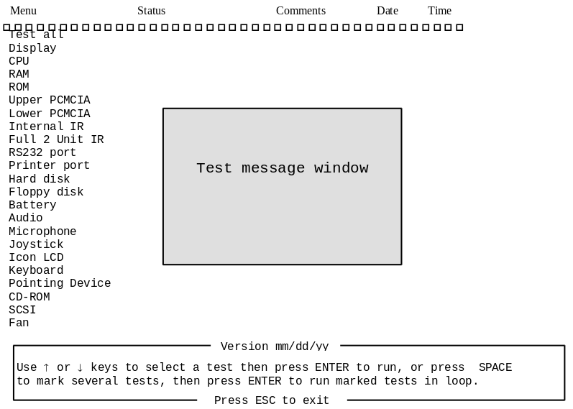
Figure 8 - Diagnostics User Interface

The current test will be displayed in inverse video. The Test message window is an area of the screen, varying in size, that individual tests use for displaying messages. If used by a test, it pops up and is then removed when the test completes. The Status column is used to display the results of individual tests. Comments will be used for additional information. Date and Time are used for looping tests.

Keys are accepted from the keyboard, an external keyboard, or the serial port. The Alt key, used in conjunction with the appropriate letter, will pop-up each menu on the screen. Refer to Table 6 for a description of each key that is available for use in the user interface.

Table 6 - Dianostic Interface Available Keystrokes
 | Key | Description
Selecting Tests | Enter | run the selected tests (marked or hightlighted)
 | Ctrl-Enter | run the alternate selected tests (marked or highlighted). See list of individual tests.
 | Space | mark or select a test
Cursor Movement | End | move highlight to end of test list
 | Home | move highlight to beginning of list
 | Up Cursor | move highlight to the previous test in list
 | Down Cursor | move highlight to the next test in list
Miscellaneous | Alt-L | toggle Logging on/off
 | Alt-C | set loop Count
 | Backspace | stops a looping test but leaves looping in effect
 | Esc | return to previous level; used to exit dialogs; from the main screen exits diagnostics causing a reset

Interpretation of test results
The test results will be displayed in the Status column of the user interface screen. Possible results are OK, Done, User Abort, Failed or a brief message indicating the type of failure. OK indicates that the test passed. Done indicates that the test has completed. See Details on Individual Diagnostic Tests beginning on page 29 for more information on each individual test.

Special test hardware requirements

Several tests within the OmniBook diagnostics program require special hardware. If the hardware is not present, the diagnostics will fail or not function properly. The below table lists the tests that require special hardware.

Table 7 - Diagnostic Tests that Require Special Hardware
Test | Required Hardware
Full 2 Unit IR | Another OmniBook running the alternate (reflecting) 2 unit IR test. See the Full 2 Unit IR test instructions on page 33.
RS-232 port | RS-232 serial loop back connector (see page 29 for diagram).
Printer port | Parallel port loop back connector (see page 29 for diagram).
Floppy disk | Formatted floppy disk which is not write protected.
Joystick | Joystick and F1181A port adapter.
CD-ROM | CD in the CD-ROM drive.
SCSI | The OmniBook must be docked.

Loop Back Connectors

In order to run the RS232 serial port or parallel port self-test, a loop back connector is needed. The loop back may be placed on either the OmniBook port or at the end of the corresponding cable. This feature is also helpful in diagnosing a defective serial or parallel cable.

Loop back connectors may be purchased or easily constructed. The following illustrations identify the correct pin-out configurations for the serial and parallel loop back connectors.

Details on Individual Diagnostic Tests
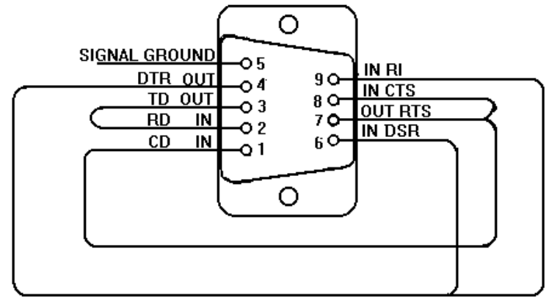
Figure 9 - Serial Loop Back Connector
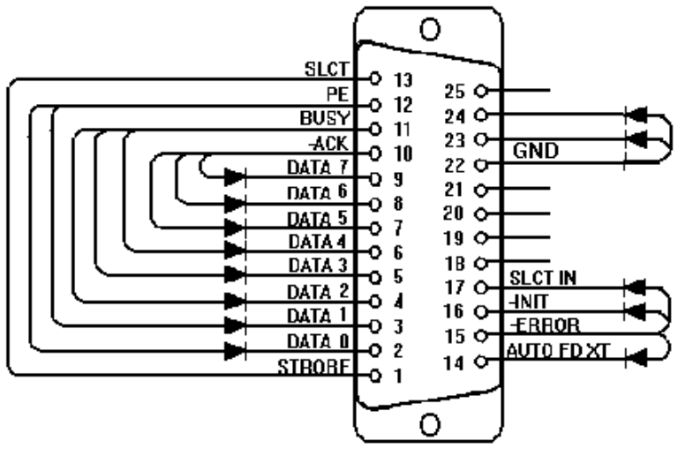
Figure 10 - Parallel Loop Back Connector

This section explains each test within the diagnostics program. Each test is listed along with its command-line file name. A brief description of the test, command-line parameters, valid keystrokes available during the test, and corresponding failure messages with error codes are also given.

Note, the term “flushed” that is used in the keystrokes sections indicates that the key is read from the key buffer and then discarded.

Test All
This is an easy way to run all the tests in sequence. However, looping does not work as expected with the Test All selection. For example, if three tests are tagged for looping and Test All is initiated, then the first two tests are executed only once. The last test in the sequence is the only test that will be looped.

Display - (DISP.COM)
The Display test executes a sequence of patterns on the screen:
- Tests video RAM, which leaves vertical lines in groups of 4.
- Draws a box around the outside edge of the display, filling the center with black.
- Fills the entire display with white.
- Fills the entire display with a 10-pixel checkerboard.
- Fills the display with horizontal lines on every 4th pixel, then steps the lines 3 times.
- Fills the display with vertical lines on every 4th pixel, then steps the lines 3 times.
- Draws 16 horizontal bars of different colors.
- Draws 16 vertical bars of different colors.
- Draws 4 horizontal shaded bands (red, green, blue, and white) with vertical tick marks.

DOS Parameter | Explanation
1, 0, or none | Wait for a key after each display pattern
2 or greater | Don’t wait for a key

Valid Keystrokes | Action
any key | When the DOS parameter is set to wait for a key, any key will step to the next display pattern; the only way to exit the test is to step through all patterns.
Esc | Aborts the test and all other keys are flushed.

Failure Message | Error Code | Meaning
User Aborted | 1 | User aborted test.
Failed | 2 | Video RAM is bad.

CPU - (CPU.EXE)
The CPU test checks the general purpose registers by copying a bit pattern through each register. Then a test of the Translation Lookaside Buffer is performed.

DOS Parameter | Explanation
none

Valid Keystrokes | Action
n/a | The CPU test ignores the keyboard.

Failure Message | Error Code | Meaning
User Aborted | 1 | User aborted test.
Failed | 2 | The register test failed.
Failed | 3 | The CPU is in protected mode, must clean boot.
Failed | 4 | The Translate Lookaside Buffer test failed.

RAM - (RAM.COM)
The RAM test checks the base 640K of RAM first, then the remainder of memory.

DOS Parameter | Explanation
none

Valid Keystrokes | Action
Backspace | Aborts the test, all other keys are flushed.

Failure Message | Error Code | Meaning
User Aborted | 1 | User aborted test.
Failed | 3 | Could not move to new code segment. RAM is bad.
Failed | 4 | CPU protected mode bit set, must clean boot.

ROM - (ROM.EXE)
The ROM test performs a 1-byte arithmetic checksum on the ROM block at address F000.

DOS Parameter | Explanation
none

Valid Keystrokes | Action
n/a | The ROM test ignores the keyboard.

Failure Message | Error Code | Meaning
User Aborted | 1 | User aborted test.

PCMCIA - (PCMCIA.COM)
The PCMCIA test sets up the TI CardBus controller chip, tests IRQ 3, and restores the chip.

DOS Parameter | Explanation
0 | Test lower slot
1 (or any non-0 value) | Test upper slot

Valid Keystrokes | Action
n/a | The PCMCIA test ignores the keyboard.

Failure Message | Error Code | Meaning
User Aborted | 1 | User aborted test.
Failed | 2 | IRQ fail

Internal IR - (FIRTEST.EXE)
This test performs a minimal test of the IR chip but does not require a second OmniBook. The Full 2 Unit IR test is a more thorough test and does require a second OmniBook (see next section).

DOS Parameter | Explanation
Internal | Performs the internal (standalone) test.

Valid Keystrokes | Action
n/a | The Internal IR test ignores the keyboard.

Failure Message | Error Code | Meaning
Must clean boot | 1 | CPU protected mode bit set, must clean boot.
Must undock | 3 | This test cannot run while docked. Can also get this error if the internal transmit failed.
Failed | 5 | Receive fail or any other fail.

Full 2 Unit IR Test - (FIRTEST.EXE)
The Full 2 Unit IR test is not available on the OmniBook 5500. This test requires two OmniBooks: one on which the IR is known to be good, and the computer to be tested. The computer that is being tested will transmit IR packets to the known good computer, which will transmit (reflect) the packets back. This method ensures both transmitting and receiving functions are checked on the computer under test.

The test checks 115200 baud, 1.152 Mbps, and 4 Mbps by sending 20 packets at each speed and looping through the 3 speeds three times for a total of 60 packets at each speed. Every received packet is checked byte for byte against the packet that was sent. Every packet must pass or the test will fail.

To run the "Full 2 Unit IR" test, perform the following steps:

- Clean boot both computers.
Windows 95 -- reboot and press <shift><F5> shortly before or after the computer displays "Starting Windows 95".
Windows for Workgroups -- reboot and press <F5> while the boot menu is displayed.

After clean booting, change to the c:\omnibook\diag directory.

- Prepare the known good computer to reflect packets to the test unit.
Run DIAG.EXE and highlight "Full 2 Unit IR" and press <CTRL> + <ENTER>. (When desired testing duration is complete, press any key to abort the reflecting end of the test.)

- Position the computer to be tested so that the IR port is in line with the IR port on the known good unit. For a simple pass/fail test, run DIAG.EXE, highlight "Full 2 Unit IR" and press <ENTER>.

DOS Parameter | Explanation
Internal | Performs the internal (standalone) loopback test. This option does not test as much of the IR hardware, but will work with just one computer. Do not use this parameter with any of the other parameters.
Reflect | Initiates the "known good" reflecting end of the full 2 unit test.
Baud=xxxxxx | Sets the baud for the first speed tested (defaults to 115200 baud). Unless /PHYTEST is also used, the 1.152M and 4M speeds will always be tested. Type in the full number for the baud to be tested (type 1152000 for 1.152Mbps, 4000000 for 4Mbps). Note -- This parameter must be used on both the known good reflecting computer and the computer under test. Both computers must start at the same speed to be able to communicate.
Loops=xxxxx | Sets the number of times to loop through the 3 speeds under test. Default = 3.
Phytest | Limits the test to just one speed which can be set with /BAUD. It also uses all null bytes rather than random data. Default speed = 115200 baud

Valid Keystrokes | Action
any key | Any keystroke will abort The Full 2 Unit IR test.

Failure Message | Explanation
OK | The test passed.
Must clean boot | A clean boot is required prior to the test (see step 1 above).
User abort | The test was aborted.
Must undock | The test cannot run when the OmniBook is docked.
No reflector unit | The computer under test did not receive back any of the packets it transmitted. Either the known good computer is not positioned properly or is not running the test (see step 2 above).
Fail | The test failed.

RS-232 Port - (RS232.COM)
Note: | This test requires a serial loopback connector to be connected to the serial port.

The RS-232 Port test reads/writes to the COM1 serial port IER, baud divisor registers, and LCR. It also checks for the loopback connector and sends a byte through the loopback connector at each of the baud rates. The RS-232 Port test is hardcoded to test the UART at 3F8, therefore, it can test only COM1.

DOS Parameter | Explanation
none

Valid Keystrokes | Action
n/a | The RS-232 test ignores the keyboard.

Failure Message | Error Code | Meaning
User Aborted | 1 | User aborted test.
Failed | 2 | No loopback connector
No loopback | 3 | Sending bytes failed
No loopback | 4 | Register read/write test failed

Printer Port - (LPT.COM)
Note: | This test requires a parallel loopback connector to be connected to the parallel port.

The Printer Port test checks the data port by writing and reading different bytes 1000 times. The loopback connector is tested by toggling data bits 0 and 1 and seeing if the PE bit gets set. Finally, all of the loopback connections are tested.

DOS Parameter | Explanation
none

Valid Keystrokes | Action
n/a | The Printer Port test ignores the keyboard.

Failure Message | Error Code | Meaning
User Aborted | 1 | User aborted test.
No loopback | 3 | Initial check for loopback connector failed.
No loopback | 4 | Data port test failed.
No loopback | 5 | Loopback connector test failed.

Hard Disk - (HDC.EXE)
The Hard Disk test verifies the presence of a hard disk, then reads/writes to the sectors. Within the user interface of Diag, pressing the Enter key invokes a short test. The short test check 1% of the cylinders and takes about a minute to complete. Pressing Ctrl-Enter runs the long test. This checks 100% of the cylinders and takes about 1.5 hours to complete.

DOS Parameter | Explanation
1, none | Only test 1% of the cylinders
N | Test N% of the cylinders

Valid Keystrokes | Action
Esc | Aborts the test, all other keys flushed.

Failure Message | Error Code | Meaning
User Aborted | 1 | Esc key pressed, or bad hard drive
Failed | 2 | No hard disk
Failed | 3 | Hard drive controller failed.

Floppy Disk - (FDC.EXE)
Note: | This test requires a formatted floppy disk to be inserted in the floppy drive.

The Floppy Disk test checks for the presence of a floppy drive with a floppy disk. If a floppy disk is not present in the drive, the test will prompt for one. At this point, a floppy disk must be inserted to continue (a reboot is necessary to abort at this stage). The sectors on the floppy disk are then tested. A complete test (100% of the sectors) takes about 1 minute and 38 seconds.

DOS Parameter | Explanation
1, none | Only test 1% of the sectors
N | Test N% of the sectors

Valid Keystrokes | Action
Esc | Once the test begins testing the floppy disk, Esc will abort; all other keys are flushed.

Failure Message | Error Code | Meaning
User Aborted | 1 | Esc key pressed, read/write fail, or write protected disk

Battery - (BATTERY.EXE)
The Battery test displays battery voltage, temperature, type, charging information, and CPU temperature.

DOS Parameter | Explanation
none

Valid Keystrokes | Action
Esc | The Battery test will run until the Esc key is pressed; all other keys are flushed.

Failure Message | Error Code | Meaning
none | n/a | The test does not return an error code.

Audio - (AUDIO.EXE)
The Audio test plays “Row, Row, Row Your Boat.” It is up to the tester to determine if the audio fails or succeeds.

DOS Parameter | Explanation
none

Valid Keystrokes | Action
n/a | The Audio test ignores the keyboard.

Failure Message | Error Code | Meaning
User Aborted | 1 | User aborted test.
Failed | 3 | A sound chip configuration call failed

Microphone - (MIKE.EXE)
Within the user interface of DIAG, the Microphone test records for a short time and then plays back what was recorded (similar to the “Rec” parameter).

DOS Parameter | Explanation
Rec | Record and play back what was recorded
On | Turns the microphone on
Off | Turns the microphone off
Gainon | Sets the gain bit in the sound chip
Gainoff | Clears the gain bit in the sound chip
Squeal | Turns the microphone on, sets the gain bit, turns the volume all the way up (so it squeals), waits for a key press, then turns off the gain bit and the microphone.
Vol n | Sets the microphone volume where n = 1 to 31 (31 being loudest)

Valid Keystrokes | Action
n/a | The Microphone test ignores the keyboard. Any keys pressed will be executed when the test finishes.

Failure Message | Error Code | Meaning
 | 1 | Parameter error

Joystick - (JOYSTICK.EXE)
Note: | This test requires a joystick and port adapter F1181A.

The Joystick test prompts to press joystick buttons and to move the pointer to various positions.

DOS Parameter | Explanation
none

Valid Keystrokes | Action
Esc | The Esc key will abort the Joystick test; all other keys are flushed.

Failure Message | Error Code | Meaning
User Aborted | 1 | Pointer movement test aborted with Esc
Failed | 2 | Joystick button test aborted with Esc

Icon LCD - (ICON.EXE)
The Icon test illuminates each segment of the icons in the icon LCD, moving from left to right. The test then flashes the entire panel three times. This is a visual test; no error codes are returned.

DOS Parameter | Explanation
none

Valid Keystrokes | Action
n/a | The Icon LCD test ignores the keyboard. Any keys pressed will execute when the test finishes.

Failure Message | Error Code | Meaning
User Aborted | 1 | User aborted test.

Keyboard - (KEYBD.EXE)
The Keyboard test consists of two types of tests: a full keyboard test, and a short keyboard test. For the full test, press the keys from left to right, top to bottom starting with Esc. For the short test, start with Pause/Break key and go clockwise around the outside of the keyboard and finish at the Scroll Lock key. Both tests skip the Fn key.

A high-pitched beep after a key press means it was the correct key and a low-pitched beep means it was incorrect. After an incorrect key is entered (low-pitched beep), the test allows four more attempts at entering the correct key.

The “Display Mode” of the keyboard test will display the number of the key as each key is pressed. The keys may be entered in any order. This mode is entered by pressing Esc during the test (as long as Esc is not the next key in the key sequence to be tested). Pressing Esc again exits display mode and resumes the keyboard test.

The DIAG.INI must be modified in order to invoke the short test within the user interface. Use the corresponding parameter explained in the below DOS Parameters table.

DOS Parameter | Explanation
1 | Perform the short test
any non-1 value | Perform the full test

Valid Keystrokes | Action
any key | To abort the keyboard test, press five, consecutive, incorrect keys.

Failure Message | Error Code | Meaning
User Aborted | 1 | User aborted test.

Pointing Device - (MOUSE.EXE)
The Pointing Device test prompts the tester to move the mouse cursor to four points on the display. The left and right mouse buttons are then tested.

DOS Parameter | Explanation
none

Valid Keystrokes | Action
n/a | The Pointing Device test ignores the keyboard. Any keys pressed will execute when the test finishes.

Failure Message | Error Code | Meaning
User Aborted | 1 | User aborted test.
Failed | 2 | Timed-out waiting for tester action (10 seconds)
Failed | 3 | TrackPoint or H8 failed

CD-ROM - (CDROM.EXE)
Note: | This test requires a CD to be inserted in the CD-ROM drive.

The CD-ROM test checks the CD-ROM controller and IRQ 15. Then a block is read and verified 10 times followed by an eject test.

DOS Parameter | Explanation
none

Valid Keystrokes | Action
Esc | The Esc key aborts the CD-ROM test; all other keys flushed.

Failure Message | Error Code | Meaning
User Aborted | 1 | User aborted test.
CD Not Ready | 2 | CD not ready, no CD in drive
H/W Error | 3 | Timeout waiting for IRQ
Drive Not Present | 4 | CD drive not installed
Read Error | 5 | The read failed

SCSI - (SCSI.EXE)
Note: | The OmniBook must be docked for this test to function properly.

The SCSI test checks for the presence of the PCI BIOS and SCSI controller. The test then checks for the presence of a SCSI hard disk, resets it, and copies the file SCSI.EXE to it.

DOS Parameter | Explanation
none

Valid Keystrokes | Action
n/a | The SCSI test ignores the keyboard.

Failure Message | Error Code | Meaning
User Aborted | 1 | User aborted test.
Failed | 2 | File copy to SCSI hard drive failed
Failed | 3 | PCI BIOS not present
Failed | 4 | SCSI controller not present
Failed | 23 | Error resetting the SCSI hard drive

Fan - (FAN.EXE)
The Fan test is not available on the OmniBook 5500. This test turns on the fan for the specified number of seconds. In the DIAG user interface, the Enter key instructs the test to run the fan for two seconds, while Ctrl-Enter runs the fan for five seconds.

DOS Parameter | Explanation
n | Number of seconds to run the fan (default=5)

Valid Keystrokes | Action
any key | Any key aborts the Fan test.

Failure Message | Error Code | Meaning
User Aborted | 1 | User aborted test.

Desktop Management Interface (DMI)

The Desktop Management Task Force (DMTF) was founded in 1992 by a group of leading computer manufacturers, including Hewlett-Packard, to define a standard method of managing the physical and logical components of personal computers. The result of these efforts is the Desktop Management Interface (DMI). The DMI package is pre-installed on the OmniBook 2000 and 5700.

Description of DMI

DMI is basically a set of rules for accessing information about a personal computer. Using DMI, an application program can determine, for example, which hardware and software components are present in a personal computer, the operating system that is being used, and the number of accessory board slots that are available. Using the DMI interface, a local or remote application program can check what hardware and software components are installed on your computer, how well they are working, and whether any needs replacing.

All this information is stored in a special Management Information Format (MIF) file, installed on each personal computer as part of the DMI package. The MIF file specifies information about components at two levels:
- Groups contain all the information concerning a particular hardware or software component. If more than one component of the same type is present, as is often the case with serial ports and hard disk drives, a group is repeated.
- Attributes are specific items of information relating to a group. Attributes of the Mouse group, for example, include the number of mouse buttons and the name and version number of the mouse driver being used.

Hewlett-Packard has developed a number of extensions to DMI to allow the enhanced features of HP OmniBook Notebook PCs to be managed with DMI. These extensions cover:
- Administrator and user passwords.
- Tattooing: a string of characters that uniquely identifies the computer.

Note: The DMI software package included with the OmniBook can only be used with the HP OmniBook Notebook PC.

For full details of the structure of the MIF file, including an explanation of the meaning of the fields of groups and attributes and how to write an application program that accesses this information, you can access the DMTF FTP server ftp.dmtf.org or the DMTF Web Pages at the URL www.dmtf.org .

Contents of the DMI Package

The DMI software and associated documentation is supplied either pre-installed on the OmniBook's hard disk drive or on two flexible disks. The contents of the package are the same in both cases.

Since the information accessed by the DMI software is specific to a particular computer, it must be installed on each computer separately.

The following software is supplied with the DMI package:
- A Microsoft Windows utility, SETUP.EXE, to install and initialize the DMI software.
- A Windows utility, HP TopTools. After DMI is installed, this utility can be used to display information about the computer through the DMI.
- A Management Information Format (MIF) file. This file contains information about everything on the computer that can be controlled using DMI facilities, and is initialized during installation.
- A component code, identifying the version of MIF file to use for specific models of HP OmniBook Notebook PCs.
- Windows-compatible DMTF Service Layer software, which controls access to the DMI.
- A client agent. The HP Remote DMI Agent is a DMI application and also a network server-side stream-based application. The Remote Agent is listening for Remote Application connection requests. If the main window of the Remote Agent is hidden, then no icon will appear on the screen when it is running.

provides a visual representation of the many components of the DMI package.

Figure 11 - DMI Components

Installing the DMI Package from Windows 95
The DMI package is included with the OmniBook, but it must be properly installed before it can be used. The following steps explain how.

Alternatively, to install the DMI from floppy disks:
- Copy the DMI software from the \omnibook\dirvers\win95\dmi directory of either the hard disk or Recovery CD to two floppy diskettes (copy the contents of the \disk1 subdirectory to diskette #1 and the contents of the \disk2 subdirectory to diskette #2).
- Start Windows 95, if it is not already running.
- Insert diskette #1 into the floppy drive.
- Select and run the SETUP program from the diskette #1.

To install the DMI preloaded on the hard disk:
- Start Windows 95, if it is not already running.
- Click on "Start".
- Go to "Programs - HP DMI".
- Select and run "SETUP".

Uninstalling the DMI Package from Windows 95
- Go to the HP DMI group.
- Launch the program "Uninstall DMI".
- Reboot the PC.

Using the DMI Interface
For a complete explanation of how to fully take advantage of DMI, the following documentation is provided with the OmniBook:
- A README.TXT file.
- A Windows online help file describing Hewlett-Packard's implementation of DMI (group and attribute definitions). Since not all Hewlett-Packard enhanced features are supported on all models, this document also describes any restrictions that apply.

System Configuration Utility

The System Configuration Utility (SCU) can be used to troubleshoot both software and hardware issues. Settings in the SCU may cause unexpected results in the operation of the OmniBook or installed applications. Battery charge and other system settings also can be verified with the SCU. The SCU settings are identical for the OmniBook 2000, 5500, and 5700, except where noted below.

The SCU is operating system independent and can be accessed by pressing F2 at boot-up or Fn+F2 at any other time. Use the <Alt> key to activate the menus and the cursor keys to navigate. The left mouse button, spacebar, and <Enter> key can also be used. The right mouse button and the <Esc> key will cancel the current action.

Main Configuration Screen

The main configuration screen of the SCU reports several system settings. See Figure 12 for an example of the main screen. The reported settings cannot be modified from the main screen; the changes must be made from the corresponding menu.

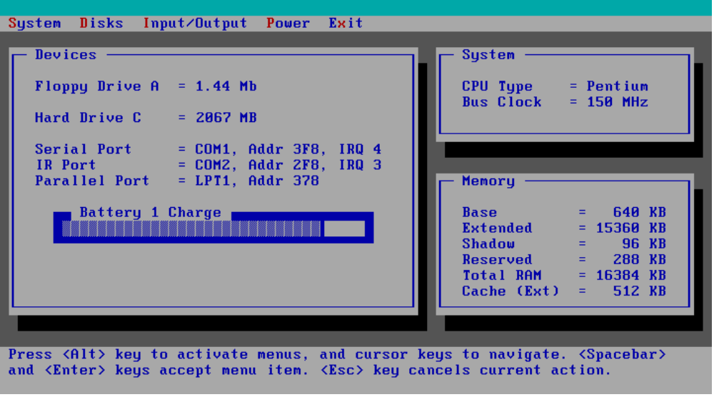
Figure 12 - Main Configuration Screen

System Menu

The system menu of the SCU provides an interface to modify several system settings. See Figure 13 for an example of the system menu. An explanation of each system setting and the corresponding options are provided in Table 8.

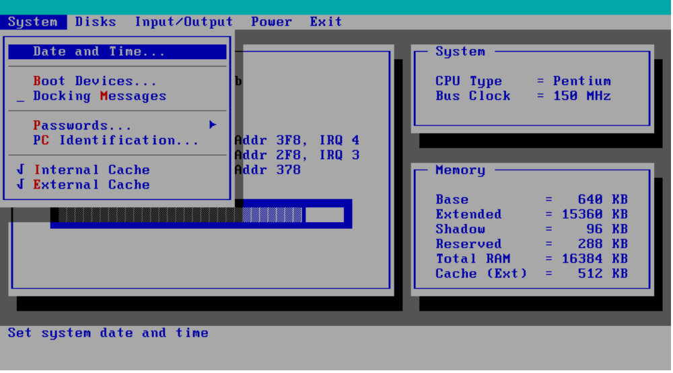
Figure 13 - System Menu Screen
Table 8 - System Menu Settings
Setting | Parameters | Default | Comment
Date and Time… | Day; Month; Year; Hour; Minute; Second
Boot Devices…
Boot Device | FDD First; HDD First | FDD First | Booting from HDD first is useful for protecting a computer from becoming infected by a boot-sector virus.
Boot Configuration | Full; Boot devices only; Auto-detect | Auto-Detect | Full configures all PnP devices; Boot devices only is used with Win95; Auto-detect will configure for the loaded OS.
Fast Boot | Selected; not selected | Not selected | Fast Boot skips RAM test.
Enable SCSI BIOS | Selected; not selected. | Not selected. | Note, this requires changing the config.sys file. In Windows 3.11 enabling SCSI BIOS maximizes available memory when a hard disk drive is the only SCSI device.
Enable boot sectorError: Reference source not found virus check | Selected; not selected. | Selected. | Displays message during boot if hard disk sector 0 (partition sector) changed since previous boot. A change could indicate a virus.
Docking Messages | Selected; not selected | Not selected | Enables warning messages at DOCK and UNDOCK.
Passwords | See Figure 14 - Passwords Menu Screen on page 47
PC Identification |  | blank | The text entered here (maximum of 4 lines of 24 characters per line) will be displayed at BOOT time. Possible text: name, address, phone number, company, or other asset tracking information.
Internal Cache | Selected; not selected | Selected | Enable internal CPU cache for faster performance.
External Cache | Selected; not selected | Selected | Enable external CPU cache for faster performance. This setting is not available on the OmniBook 2000.

Passwords Menu
The password option of the system menu provides an interface to enter and modify administrator and user passwords. See Figure 14 for an example of the password menu. An explanation of each password option is provided in Table 9.

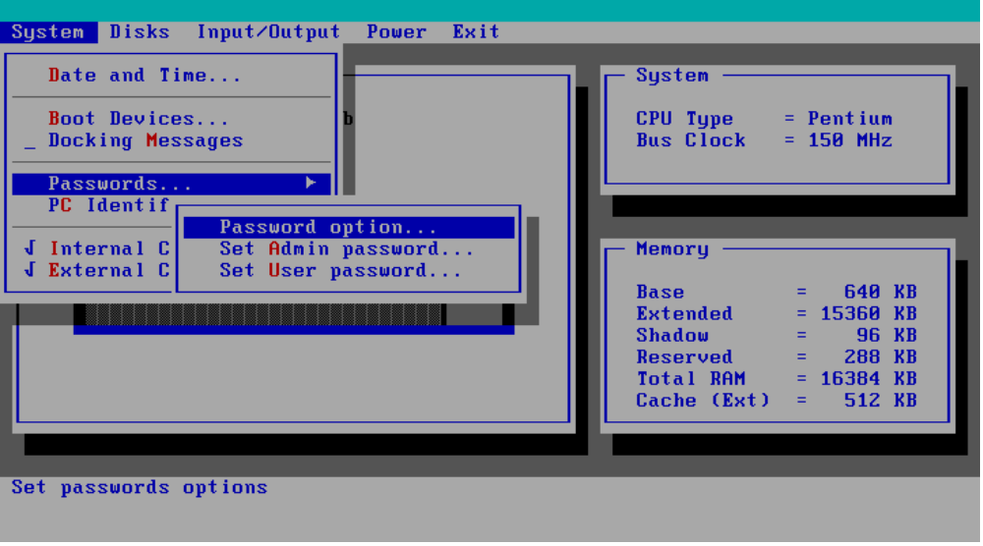
Figure 14 - Passwords Menu Screen

Table 9 - Password Menu Settings
Setting | Parameters | Default | Comment
Passwords…
Password option…
Admin Password required to: | Save modifications to PC ID texts  Save Setup changes | none selected | Admin Password is required before proceeding beyond the selected actions. The Admin Password (if defined) is ALWAYS required to save changes to these checkboxes.
User Password required to: | Turn ON, Always;  Turn ON, after FN+Suspend;  Undock;  Save Setup changes | none selected | Password is required before proceeding beyond the selected actions, and is ALWAYS required to save changes to these checkboxes. Admin Password can be used in place of any User password.
Disable hard disk drive lockError: Reference source not found | Selected; Not selected | Not selected. | Check to remove password locking of the hard disk.
Set Admin password |  | none | Allows entry of Admin password.
Set User password |  | none | Allows entry of User password.

Disks Menu

The disks menu of the SCU provides an interface to modify floppy and hard disk drive parameters. See Figure 15 for an example of the disks menu. An explanation of each disk parameter is provided in Table 10.

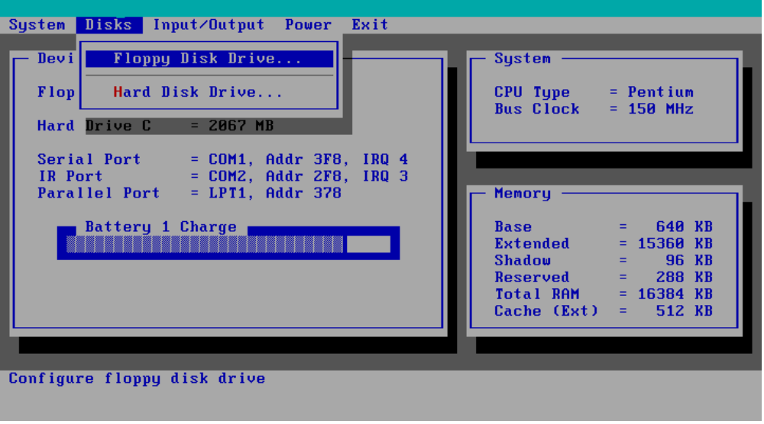
Figure 15 - Disks Menu Screen
Table 10 - Disks Menu Settings
Setting | Parameters | Default | Comment
Disks
Floppy Disk Drive | None  1.44 Mb  2.88 Mb | 1.44 Mb
Hard Disk Drive | None  Standard  Custom  Auto-ID | Auto-ID | Select the configuration type of the hard disk. ‘Standard’ selects from a table of older drivers. ‘Custom’ allows manual modification of drive parameters. ‘Auto-ID’ will attempt to automatically type an IDE drive. (This screen also reports # cylinders, # heads, sectors/track, landing zone, write precomp, type code, and size).

Input/Output Menu

The input/output menu of the SCU provides an interface to modify serial and parallel port parameters and other external device settings. See Figure 16 for an example of the password menu. An explanation of each password option is provided in Table 11.

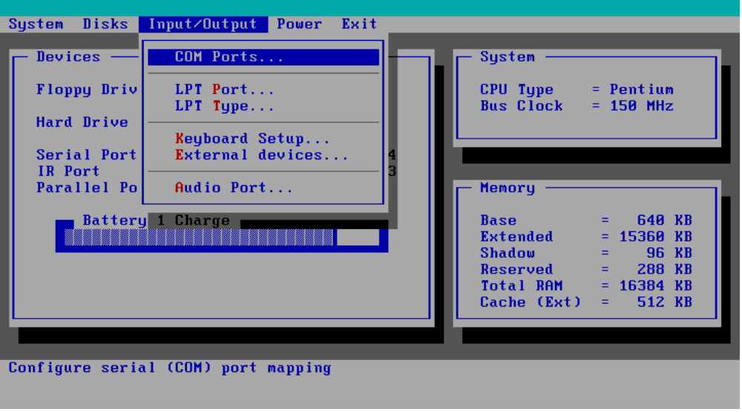
Figure 16 - Input/Output Menu Screen

Table 11 - Input/Output Menu Settings
Setting | Parameters | Default | Comment
COM Ports…
Serial Port: | None  COM1, Addr 3F8, IRQ 4  COM2, Addr 2F8, IRQ 3  COM3, Addr 3E8, IRQ 4  COM4, Addr 2E8, IRQ 3 | COM1, Addr 3F8, IRQ 4
IR Port | None  COM1, Addr 3F8, IRQ 4  COM2, Addr 2F8, IRQ 3  COM3, Addr 3E8, IRQ 4  COM4, Addr 2E8, IRQ 3 | COM2, Addr 2F8, IRQ 3
LPT Port
Printer Port | None  LPT1, Addr 378  LPT2, Addr 278  LPT3, Addr 3BC | LPT1, Addr 378
LPT Type
Port Definition | Standard AT (Centronics)  Bidirectional (PS-2) | Bidirectional (PS-2)
Keyboard Setup…
Key Delay | ¼ sec; ½ sec; ¾ sec; 1 sec | ½ sec | Select the delay period to wait (after a key is pressed) before it will begin to repeat.
Key Repeat Rate | 2 cps; 6 cps; 10 cps; 15 cps; 20 cps; 30 cps | 10 cps | Select the rate at which keys will be repeated when they are held down longer than the Key Delay period.
Keyboard Numlock | Selected, Not selected | Not selected | Start computer with NUM LOCK enabled.
External Devices…
VGA Display device | External VGA if attached, LCD off;  Both external VGA and LCD | External VGA if attached, LCD off; | When ‘External VGA…’ is selected, if an external VGA monitor is detected, it will be enabled and the LCD will be turned off. When ‘Both external VGA and LCD’ is selected, both are ALWAYS on.
Television Type | NTSC; PAL | NTSC | Select the television type. This setting is available only on the OmniBook 5500.
Force recognition of external VGA | Selected; Not selected | Not selected | Available only when Both external VGA and LCD is selected. This setting not available on the OmniBook 5500.
Enable External FN Key | Selected; Not selected | Selected | When enabled, CTRL + ALT on external keyboard acts as FN key.
Ignore External Pointing Device | Selected; Not selected | Not selected
Audio Port…
Audio volume | 0-7 | 7
Beeper volume: | 0-7 | 3 | .

Power Menu

The power menu of the SCU provides an interface to modify various power management and battery charging configurations. See Figure 17 for an example of the password menu. An explanation of each power option is provided in Table 12.

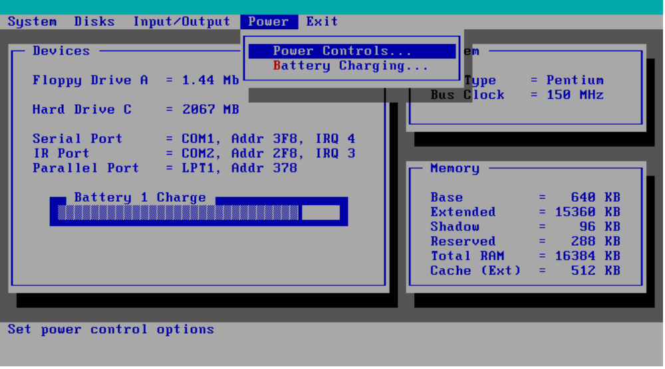
Figure 17 - Power Menu Screen
Table 12 - Power Menu Settings
Setting | Parameters | Default | Comments
Power Controls
Power Saving | Off/On | On | Enables power saving techniques (APM).
Suspend | Disable/Time  (1 - 30 minutes or never) | 3 minutes | When the system has been idle for the selected period, the computer will suspend. This setting not available on the OmniBook 5500.
Auto Hibernate (Save-to-Disk) | Disable/Time  (6 hours to 7 days or never) | 1 day | If the system has been suspended for the selected period, the entire state of the computer will be saved to the hard disk, and the computer will be fully powered down.
HDD power-down | Disable/Time  (1-30 minutes or never) | 3 minutes | The hard disk will be powered down if there have been no disk accesses for the selected period. Hard disk power will be restored when the disk is needed again.
CPU power-down | Disable/Time  (512 ms-8 seconds or never) | 2 sec | The CPU clock rate will be reduced (i.e. slower performance) if the system has been idle for the selected delay. The clock rate will be restored when system activity is detected. Only applicable when APM is inactive.
Enable hibernate (Save-to-Disk) | Selected; not selected | Selected | Enables hibernate (disable to free up hard drive space).
Timeout during screen activity | Selected; not selected | Not selected | Allows timeout (suspend) during screen activity (like screen savers).
HDD power-down when on AC | Selected; not selected | Selected | Allows the hard disk drive to spin down while AC power is connected.
Disable low battery messageError: Reference source not found | Selected; not selected | Not selected | Inhibits display of BIOS low battery warning message. Does not affect reporting of battery status by operating systems.
Battery Charging | None  Most drained first  Least drained first  Battery #1 first  Battery #2 first | Most drained first

Exit Menu

The exit menu of the SCU allows various methods of exiting the interface. See Figure 18 for an example of the exit menu. An explanation of each exit option is provided in Table 13.

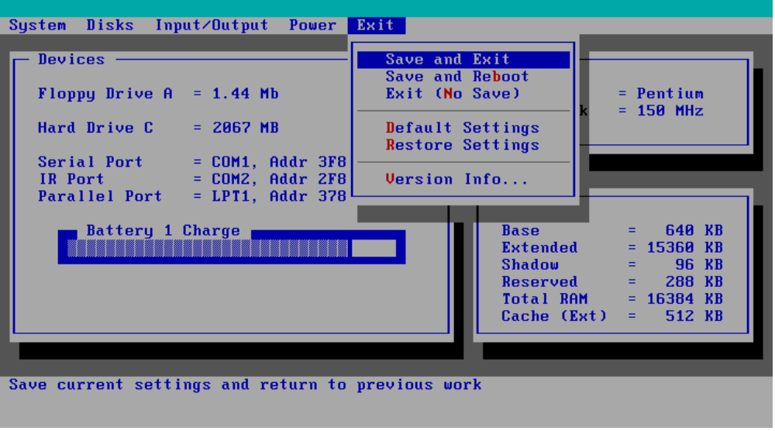
Figure 18 - Exit Menu Screen

Table 13 - Exit Menu Settings
Setting | Parameters | Default | Comment
Save and Exit | n/a | n/a | Save current settings and return to previous work.
Save and Reboot | n/a | n/a | Save current settings and reboot so that settings take effect.
Exit (No Save) | n/a | n/a | Exit without saving current settings.
Default Settings | n/a | n/a | Set current setup to default settings.
Restore Settings | n/a | n/a | Restore current setup to original settings.
Version Info… | n/a | n/a | Report current BIOS version information.

Troubleshooting Tips

Presented below is a table showing general guidelines for repairing units with specific failure symptoms. The order of likely causes is based upon data gathered by HP from analysis of failed modules. The suggested order of investigation is not mandatory but reflects the priority HP would currently place on looking for the root cause.

Swapping of easily replaced modules with known good reference modules is the ideal way to isolate the cause down to the module level. It is rare for more than one module to be responsible for the same failure symptom. Therefore, replacement of more than one module for a particular symptom should be the exception rather than the normal expectation.

After replacing modules, it is normal for some units to end up in a confused state and lock up when ac power is applied. If this occurs, the reset button should be pressed to bring the computer to a known state. If the unit still locks up or continues to lock up each time ac power is applied, the unit needs additional analysis.

Table 14 - OmniBook Troubleshooting Tips
Symptom | Call Center | Likely Cause (in order) | Comments
Battery
Won’t run on battery — no bars in battery icon | - Try known good battery in suspect unit  - Try suspect battery in known good unit  - Send in for repair | - Battery  - PT-586
Battery won’t charge — light blinks | - Try known good battery  - Send in for repair | - Battery
Battery won’t charge — no charge indicators | - Try known good battery in suspect unit  - Try suspect battery in known good unit  - Send in for repair | - PT-586 | - Possible solder problem on RT1
- Hard Disk Drive
HDD doesn’t spin at all | - Verify known good power source  - Reseat HDD  - Send in for repair | - PT-586  - HDD  - HDD flex cable  - HDD plastic kit | - If the HDD plastic kit is bent or otherwise misshapen, the HDD may not function properly.
- Display
Dark display — no light | - Ensure contrast/brightness button is installed properly  - Adjust contrast/brightness  - Send in for repair | - Broken backlight tube | - Replace display
- Video problems — appears horizontal hold is out | - Send in for repair | - Display connector not seated correctly. | - Lift up icon assy — push down on left display connector.
- Keyboard
Keyboard errors — 2 characters on a keystroke instead of one | - Send in for repair | - PT-586  - PT-DC  - Keyboard | - Damaged U10  - Shorted pins on connectors
- Keyboard errors — no response from key(s) | - Send in for repair | - PT-DC  - PT-586  - Keyboard | - Possible bad connector solder joints
- Keyboard doesn’t respond, audio slow, battery problems | - Send in for repair | - PT-586 | - Damaged U10
- Unit Hangs or Won’t Boot up
Won’t boot up & no display | - Verify known good power source  - Push reset button  - Try pulling RAM module and re-inserting  - Send in for repair | - PT-CPU  - RAM module  - PT-DC  - PT-586  - PT-ICON | - Swap with reference CPU to check. Replace original CPU if not fixed.  - Make sure RAM is seated properly — remove and re-install to check.
- Unit hangs at Win95 screen during boot | - Eliminate any s/w configuration conflicts  - Send in for repair | - PT-586 | - Possible burnt R92 hangs up audio IC
- Unit locks up after 2-3 minutes | - Run BIOS upgrade program  - Send in for repair | - PT-ICON | - Corrupt EEPROM — run BIOS upgrade
- Unit goes into suspend after “Bridge controller” message, won’t resume | - Send in for repair | - PT-586 | - Damaged U10
- TrackPoint/Cursor
Cursor pointer drifts slightly. | - It is normal for the cursor to drift slightly as the circuit does | - Keyboard and palmrest. | - Be sure keyboards are tested with the correct palmrest. The latest
- Cursor pointer “flying” or drifting excessively. | a self calibrate every once in a while  - Send in for repair. | - Mismatched palmrest and keyboard pair | TrackPoint sensor (CTS) must match up with a CTS palmrest. Mismatched keyboards and palmrests result in the cursor moving
Cursor moves in the opposite direction of TrackPoint movement |  |  | in the opposite direction of intended movement.  - Refer to Service Note 5500-04.
- Miscellaneous
Loses time | - Plug AC adapter into unit and let it charge for at least 24 hours.  - Send in for repair if still losing time. | - PT-586 Philips IC  - Sub-battery Discharged  - Flex cable (F1320-60950)  - PT-586 U46 or Y3 crystal IC | - Refer to Service Note 5500-01 for IC problem and 5500-07 for backup battery problem (should be >4.8V).  - Replace PT-586
- PCMCIA failure | - Check device manager in Win95 for resource conflicts  - Send in for repair | - PT-586 | - Also check for configuration problems
- Slow audio and display | - Send in for repair | - PT-CPU | - Check for loose heat sink screws — tightening should fix  - Check CPU fan for correct operation (use OmniBook diag program).
- Computer gets hot | - It is normal for the computer to get warm/hot especially with 150 & 166 MHz MMX CPU and if charging the battery. Try using the fold down legs to raise the back of the machine to promote air flow.  - On OB2000 and OB5700, ensure air vents are clear.  - Send in for repair | - PT-586  - PT-CPU  - RAM modules | - Check CPU fan for correct operation (use OmniBook diag program).

Part 3

Hardware Repair
- Battery
- Memory
- Hard Disk Drive
- Floppy Disk Drive
- Small Parts
- Display
- Keyboard
- Icon Board
- CPU Module
- Logic PCA Board
- Programmable Flash BIOS IC
- Video Memory
- Other Components and Accessories
Caution: | Always provide proper grounding when performing any of the following repairs. An electrostatic discharge may cause irreparable damage to the OmniBook and its components.

Battery
(End User Replaceable)

The OmniBook 2000 and 5700 must use the F1193B (F1193-60902) Standard Lithium Ion battery or the F1194B (F1194-60902) Enhanced Lithium Ion battery. Both of these batteries are fully compatible with the OmniBook 5500. Do not use either the F1193A (F1193-60901) or F1194A (F1194-60901) battery in the OmniBook 2000 or 5700 as data corruption may occur on the hard disk drive.

Warning: | Do not mutilate, puncture, or dispose of batteries in fire. The batteries can burst or explode, releasing hazardous chemicals. A rechargeable battery pack must be recycled or disposed of properly.

Table 15 - Battery Compatibility Matrix
Battery | Description | Part Number | OB2000 | OB5500 | OB5700
F1193A | Standard LiIon | F1193-60901 |  | ü
F1193B | Standard LiIon | F1193-60902 | ü | ü | ü
F1194A | Enhanced LiIon | F1194-60901 |  | ü
F1194B | Enhanced LiIon | F1194-60902 | ü | ü | ü

Required Equipment
- none

Removal Procedure
- Slide the battery release switch to the right and slide the battery out of its compartment. See Figure 19 - note, this perspective is with the OmniBook upside down, which is not necessary.
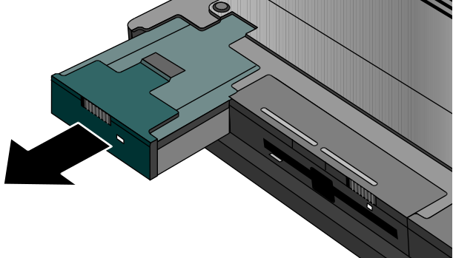
Figure 19 - Removing the Battery

Replacement Procedure
- Reverse the above Removal Procedure.

Memory
(End User Replaceable)

Caution: | To avoid damage due to electrostatic discharge, handle the memory module by the edges only.

The table below lists each of the available memory modules for the OmniBook 2000, 5500, and 5700. The check marks indicate which memory modules are compatible with each OmniBook.

Table 16 - Memory Compatibility Matrix
Memory | Part Number | Exchange p/n | OB2000 | OB5500 | OB5700
8-MB | F1134-60901 | F1134-69001 | ü | ü | ü
16-MB | F1135-60901 | F1135-69001 | ü | ü | ü
32-MB | F1136-60901 | F1136-69001 | ü | ü | ü
64-MB | F1335-60901 | F1335-69091 | ü |  | ü

Required Equipment
- Flat-bladed prying device (or fingernail)

Removal Procedure
- Exit all applications, including Windows.
- Remove the ac adapter and battery(ies) from the OmniBook.
- Use a flat-bladed prying device (or fingernail) to remove the cover from the memory-expansion slot.
- Pull out the memory board by lifting up on the removal tab. See Figure 20.
Memory Cover
F1320-60927
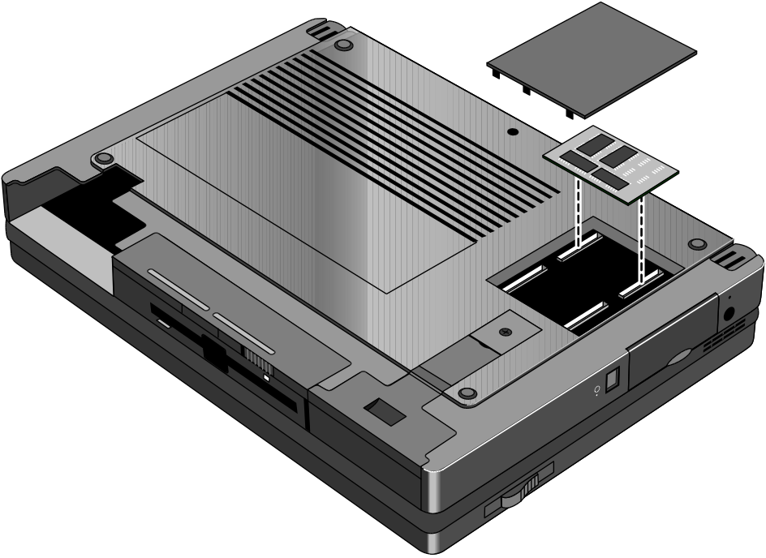
Figure 20 - Removing Memory
Memory Module

Replacement Procedure
- Align the memory module over the connector slots and firmly press into place.

Caution: | Avoid pressing the center of the memory module. This action could crack the board.

- Replace cover and battery(ies) and reset the OmniBook.

Hard Disk Drive
(End User Replaceable)

Whereas all the hard disk drives are compatible between the OmniBook 2000, 5500, and 5700, the table below indicates which hard drives were originally shipped with each corresponding OmniBook.

Table 17 - Hard Drive Availability Matrix
Hard Drive | Part Number | Exchange p/n | OB2000 | OB5500 | OB5700 | Hard Drive Plastic Kit Part #
810-MB | F1191-60901 | F1191-69001 |  | ü |  | F1320-60947
1.35-GB | F1192-60901 | F1192-69001 |  | ü |  | F1320-60947
2.1-GB | F1339-60901 | F1339-69001 | ü |  | ü | F1350-60920
3.1-GB | F1348-60901 | F1348-69001 |  |  | ü | F1350-60920
1.44-GB | F1375-60901 | F1375-69001 | ü |  |  | F1350-60920

Required Equipment
- Small phillips screwdriver

Removal Procedure
- Exit all applications, including Windows.
- Turn the OmniBook off and remove the battery and ac adapter.
- Remove the screw and Security Cover located at the back end of the hard disk drive. See Figure 21.
Hard Drive Screw
F1320-60919
Hard Drive Security Cover
F1320-40001
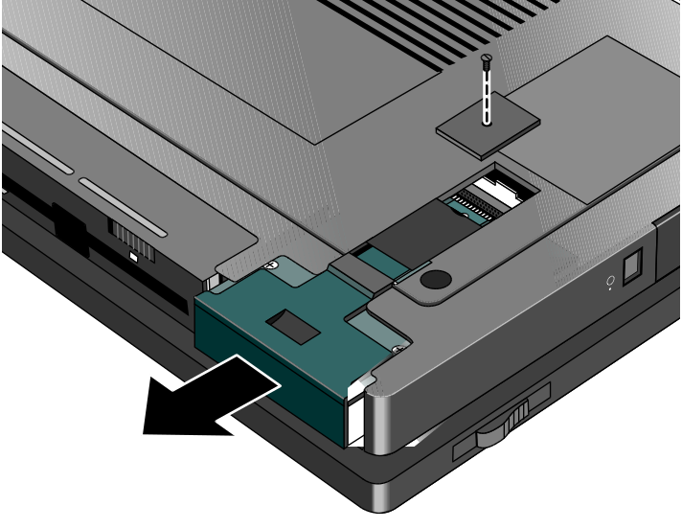
Figure 21 - Removing the Hard Disk Drive
- Firmly slide the drive out of the compartment. This will take some force.
- If the new hard drive does not have a plastic case, the old plastic case can be removed from the old hard drive by removing the four screws on the bottom of the case. Depending on the manufacturer of the replacement hard drive, the screw hole placement may vary. The plastic portion of the hard drive may need to be removed to gain access to the screws of the plastic kit. See Figure 22.
- Now, the hard drive can be slid out of the case. See Figure 23.
Figure 22 - Hard Drive Case
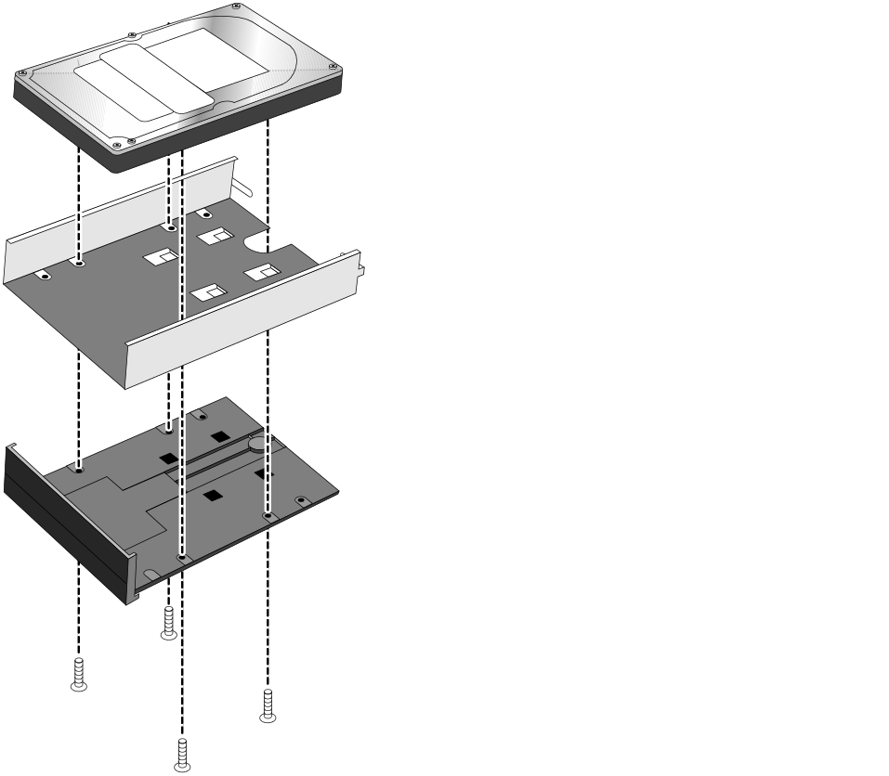
Figure 23 - Removing the Hard Drive Plastic Kit
Hard Drive Plastic Kit
F1350-60920 - OB2000 & OB5700
F1320-60947 - OB5500 only
Hard Drive

Replacement Procedure
- Reverse the above Removal Procedure.

Floppy Disk Drive
(End User Replaceable)

Caution: | Do not remove the floppy disk drive while the OmniBook is actively reading or writing to it. Wait until the disk is inactive.

Required Equipment
- none

Removal Procedure
- Slide the release switch on the floppy disk drive to the right.
- Pull the pull-tab firmly to remove the floppy drive from the compartment. See Figure 24 - note, this perspective is with the OmniBook upside down, which is not necessary.

Pull-tab
Floppy Disk Drive
F1195-60901
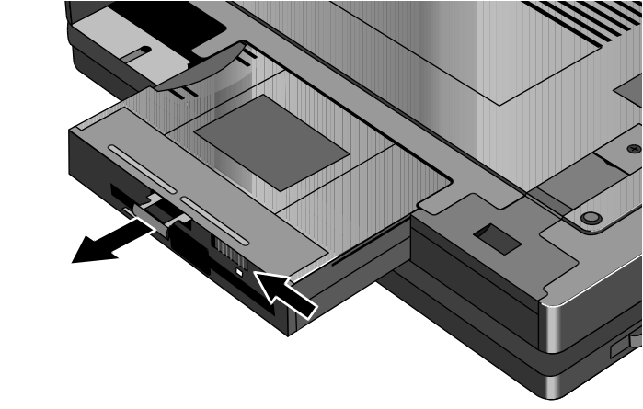
Figure 24 - Removing the Floppy Disk Drive
Release Switch

Replacement Procedure
- Reverse the above Removal Procedure.

Small Parts
(End User Replaceable)

The following small parts are all end user replaceable. The procedures are the same for the OmniBook 2000, 5500, and 5700, except where noted.

Expansion Door - F1125-60920
Open the door and flex the center of the door until the side-tabs are released. Reverse to replace.

Display Contrast/Brightness Slider Button - F1371-60917
Use a blunt probe to gently pry the slider button from the display. To replace, align the button’s prongs over the contrast/brightness post and press firmly into place.

Door, Flash BIOS - F1371-60901
On the OmniBook 2000, remove the screw securing the door and lift the door off the bottom case. Replace the door and screw. The OmniBook 5700 will have this feature added at a later date; the OmniBook 5500 will not.

Hard Drive Security Cover - F1320-40001
Use a small phillips screwdriver to remove the hard drive screw and security cover. Reverse to replace.

I/O Door - F1350-60910 (OB2000 & OB5700), F1320-60928 (OB5500 only)
Open the door and flex the center of the door until the side-tabs are released. Reverse to replace.

Memory Cover - F1320-60927
Use a flat-blade prying device or fingernail to pry the memory cover off. To replace, snap the cover into position.

PCMCIA Button Assembly - F1320-60949
“Unfold” the button, grasp firmly, and pull free. Reverse to replace.

Plastic Feet - F1320-60929
Flip the foot into an “open” position. Twist the foot to remove. Reverse to replace.

Printer Port Door - F1125-60918
Open the door and flex the center of the door until the side-tabs are released. Reverse to replace.

Rubber Feet - F1320-60957
Place a probe or similar device between the rubber foot and the plastic of the bottom case. Pry upward to pop the foot out. To replace, firmly press the foot into the hole.

Trackpoint™ Cap - F1320-60971
Grasp the cap firmly and pull upward. Reserve to replace.

Display
(HP Authorized Service Providers Only)

The below table summarizes the compatibility of displays between the OmniBook 2000, 5500, and 5700. Please note, that the proper Icon Board must be matched with the corresponding display type and manufacturer.

Table 18 - Display Compatibility Matrix
Display Part # | Display Type | OB2000 | OB5500 | OB5700 | Icon Board | Part Number
F1320-69004 | 10.4” TFT |  | ü |  | PCA PT-ICON | F1320-60924
F1320-69005 | 11.3” DSTN |  | ü |  | PCA PT-ICON | F1320-60924
F1320-69006 | 12.1” TFT Hitachi* | ü | ü | ü | PCA PT-ICON | F1320-60924
 |  |  |  |  | PCA PB-ICON/SVGA | F1350-60907
F1320-69094 | 12.1” TFT Samsung* | ü | ü | ü | PCA PT-ICON/SMGError: Reference source not found | F1320-60993
 |  |  |  |  | PCA PB-ICON/SVGAError: Reference source not found | F1350-60907
F1350-69002 | 12.1” TFT XGA |  |  | ü | PCA PB-ICON/XGA | F1350-60908
F1371-69006 | 12.1” DSTN | ü |  |  | PCA PB-ICON/DSTN | F1371-60911
* At the time of this printing, Samsung is considered the primary supplier of 12.1” TFT displays. Unless otherwise indicated, all 12.1” TFT SVGA orders should be placed against F1320-69094. However, this is subject to change without notice.

Required Equipment
- Small phillips screwdriver

Removal Procedure
- Exit all applications, including Windows.
- Turn the OmniBook off and remove the battery and ac adapter.
- Follow the Hard Disk Drive Removal Procedure on page 65.
- Turn the unit over and remove the two display screws located under the plastic feet. See Figure 25 on page 70.
- Turn the unit back over and remove the Icon Assembly by applying pressure with the thumbs. See Figure 26 on page 70. Note, it is helpful to lift up on the display slightly.
- The Icon Assembly flex cable may be disconnected at this point to completely remove the Icon Assembly, however, it is not necessary for the removal of the display.
- With the Icon Assembly either removed or out of the way, disconnect the Display Cables and the two Display Grounding Cables. See Figure 27 on page 71.

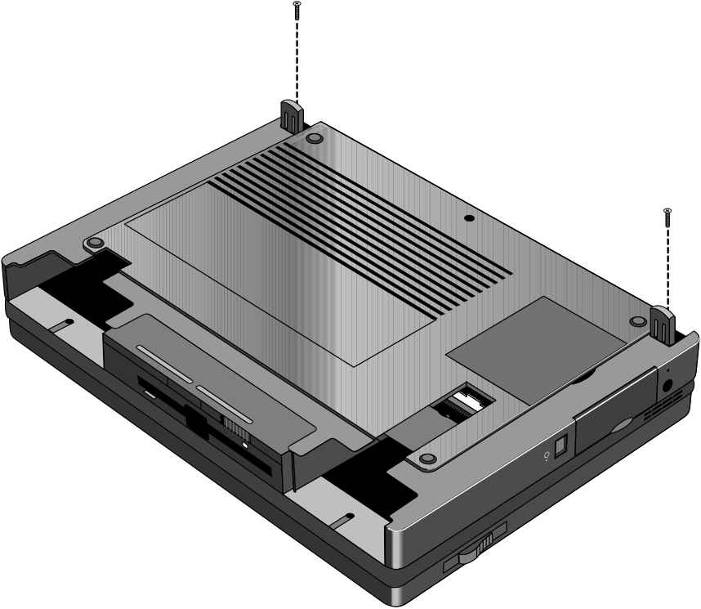
Figure 25 - Display Screws
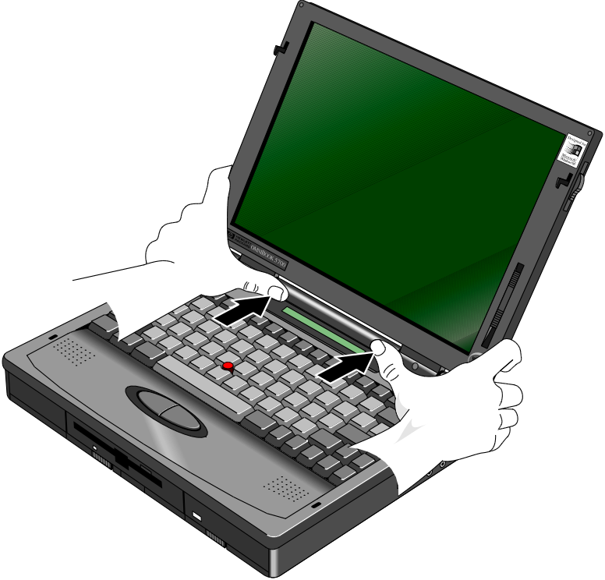
Figure 26 - Icon Assembly Removal
Display/Chassis Screws
F1081-60939
(qty 2)

Display Cables
Display Grounding Cable
Display Grounding Cable
Display/Chassis Screws
F1081-60939
(qty 2)
Figure 27 - Display Cables

Replacement Procedure
- To replace, reverse the above Removal Procedure. Take care to properly position the Display Flex Cable. It must be wrapped three times around the post. See Figure 28.

Caution: | To avoid crimping the icon assembly flex cable, ensure that it is tucked inside of the icon assembly “tunnel.”
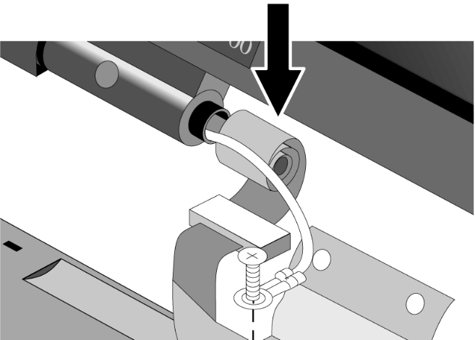
Figure 28 - Display Flex Cable Position

Display Labels

The OmniBook replacement display must be affixed with four labels before it is suitable to return to the customer. The below table summarizes the proper labels for each OmniBook and display type. The illustrations that follow demonstrate the appropriate placement of the Windows 95, Intel, and OmniBook model labels for each of the three display sizes available.

Table 19 - Display Label Compatibility Matrix
Display Size/Type | OmniBook Model | HP OmniBook Label | Windows 95 Label | OmniBook Model Label | Intel Inside Label
12.1” DSTN SVGA | 2000CS | F1065-80005 | 7121-7353 | F1371-60913 | 5182-5113
12.1” TFT SVGA | 2000CT | F1065-80005 | 7121-7353 | F1371-60912 | see footnote
11.3” DSTN SVGA | 5500CS | F1065-80005 | 7121-7353 | F1320-60969 | 5182-5113
10.4” TFT SVGA  12.1” TFT SVGA | 5500CT | F1065-80005 | 7121-7353 | F1320-60970 | 5182-5113
12.1” TFT SVGA | 5700CT | F1065-80005 | 7121-7353 | F1350-60917 | 7121-7455
12.1” TFT XGA | 5700CTX | F1065-80005 | 7121-7353 | F1350-60918 | 7121-7455

30 mm
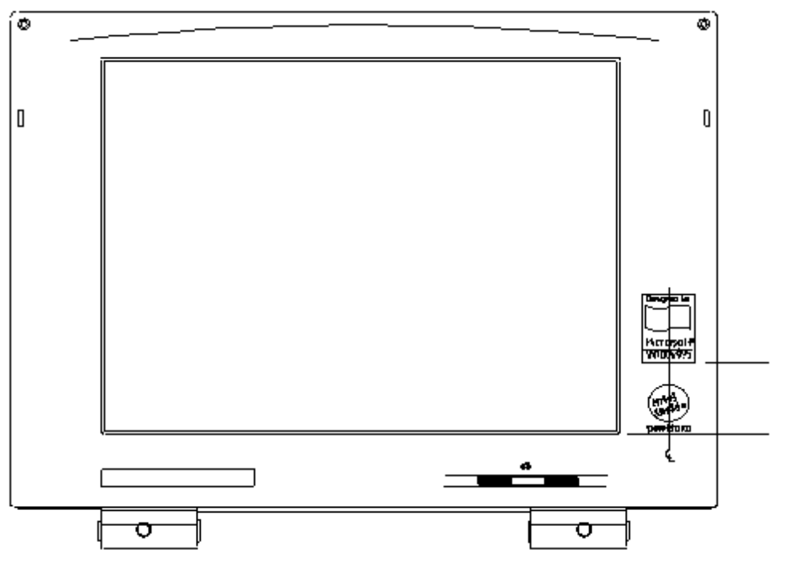
Figure 29 - 10.4" Display Label Placements
OmniBook Model Label
Intel Label
Windows 95 Label
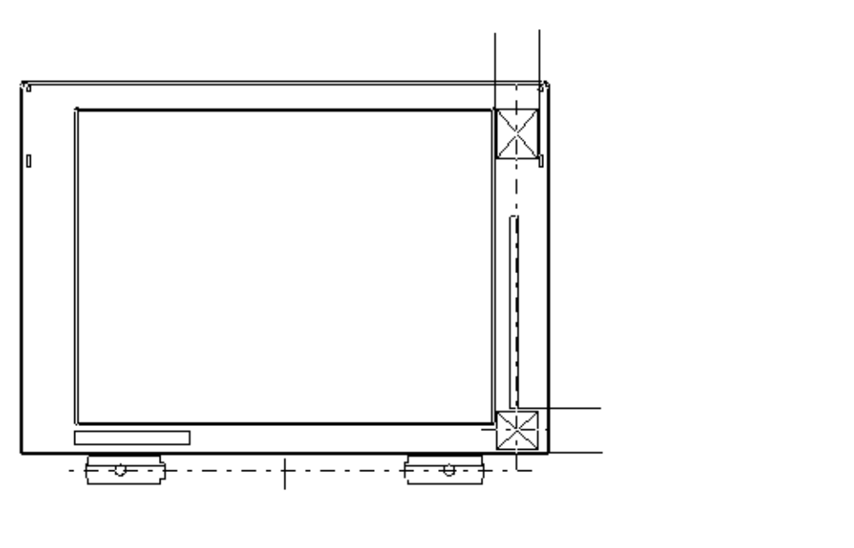
Figure 30 - 11.3" Display Label Placements
Windows 95 Label
Intel Label
OmniBook Model Label
Center vertically between brightness and bottom of display panel.
Align with center of Windows 95 label.
Align top edge with edge of display opening.

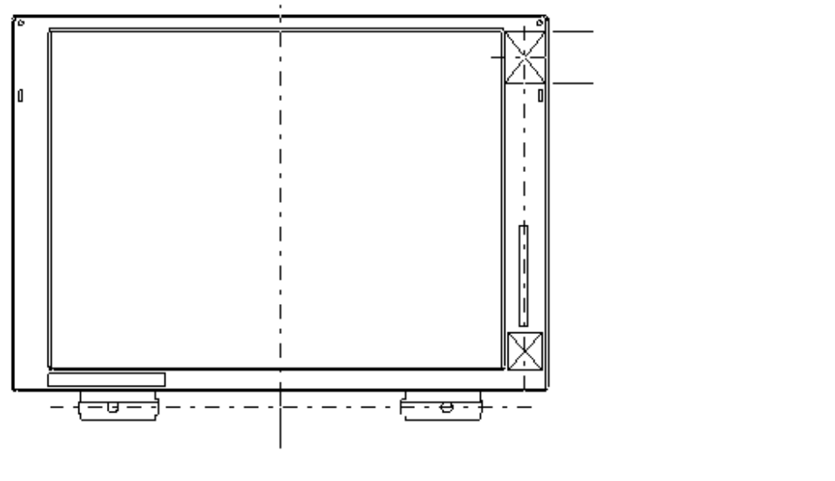
Figure 31 - 12.1" Display Label Placements
Windows 95 Label
Intel Label
OmniBook Model Label
Center vertically between latch opening top edge and rubber bumper bottom edge.
Align bottom edge with bottom edge of display opening.
Center both labels horizontally in space permitted.

Keyboard
(HP Authorized Service Providers Only)

Required Equipment
- Small phillips screwdriver

Removal Procedure
- Exit all applications, including Windows.
- Turn the OmniBook off and remove the battery and ac adapter.
- Follow the Hard Disk Drive Removal Procedure on page 65 and the Floppy Disk Drive Removal Procedure on page 67 to remove these components.
- Remove the four Palmrest Screws (see Figure 32 for the location of the screws – Note, the Display is shown removed for illustrative purposes; it is not necessary for the repair procedure).

Figure 32 - Palmrest Assembly Removal
Palmrest Screws
F1081-60942
(qty 4)

- Flex the center of the Palmrest Assembly to release the side-tabs. Disconnect the Keyboard Flex cable. The other two cables can remain in place, or disconnect to fully remove the Palmrest Assembly.
- Remove the four Keyboard Screws (see Figure 33 for the location of the screws).

Figure 33 - Keyboard Screws
Keyboard Screws
F1320-60920
(qty 4)

- Lift up the Keyboard – be sure to thread the Keyboard Flex Cable underneath the plastic of the Upper Chassis Case.
- To remove the Keyboard further, the DC Power Supply Board must be removed. Pull up evenly on both tabs of the Power Board. See Figure 34.

Caution: | Applying uneven pressure when removing the Power Board may cause damage to the connector pins.

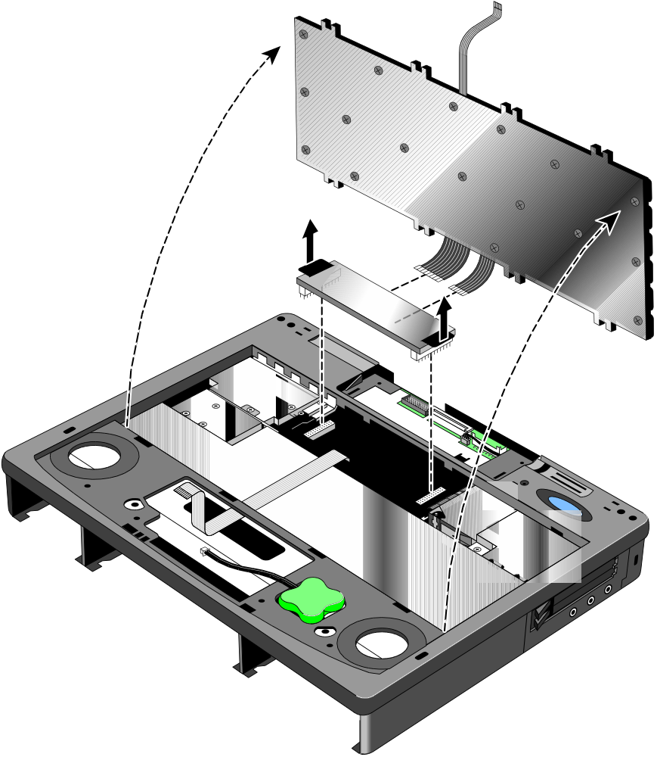
Figure 34 - Keyboard Removal
DC Power Supply Board
F1350-60909 - OB2000 & OB5700
F1320-60925 - OB5500 only

- Disconnect the two flex cables from the Power Board.

Replacement Procedure
- Reverse the above Removal Procedure. Take note to properly thread the Keyboard Flex Cable underneath the plastic of the Upper Chassis Case.

Icon Board (PCA PB-ICON)
(HP Authorized Service Providers Only)

The table below lists the icon boards compatible with the OmniBook 2000, 5500, and 5700. Note the column indicating the matching LCD type (the icon boards and LCD types must not be mismatched). There are no exchange part numbers for any of the icon boards.

Table 20 - Icon Board Compatibility Matrix
Icon Board | Part Number | OB2000 | OB5500 | OB5700 | LCD Type/Mfg. | LCD Part #
PCA PT-ICON | F1320-60924 |  | ü |  | All/Hitachi | see footnote
PCA PT-ICON/SMG | F1320-60993 |  | ü |  | 12.1 TFT/Samsung | F1320-69094
PCA PB-ICON/SVGA | F1350-60907 | ü |  | ü | SVGA TFT | F1320-69094  F1320-69006
PCA PB-ICON/XGA | F1350-60908 |  |  | ü | XGA TFT | F1350-69002
PCA PB-ICON/DSTN | F1371-60911 | ü |  |  | DSTN | F1371-69006

Required Equipment
- Small phillips screwdriver

Removal Procedure
- Exit all applications, including Windows.
- Turn the OmniBook off and remove the battery and ac adapter.
- Follow the Display Removal Procedure on page 69 and the Keyboard Removal Procedure on page 72 to remove these components.
- Remove the Upper Chassis Case Screw and disconnect the On/Suspend Button and Microphone Cables. Lift the Upper Chassis from the base of the unit. See Figure 35.

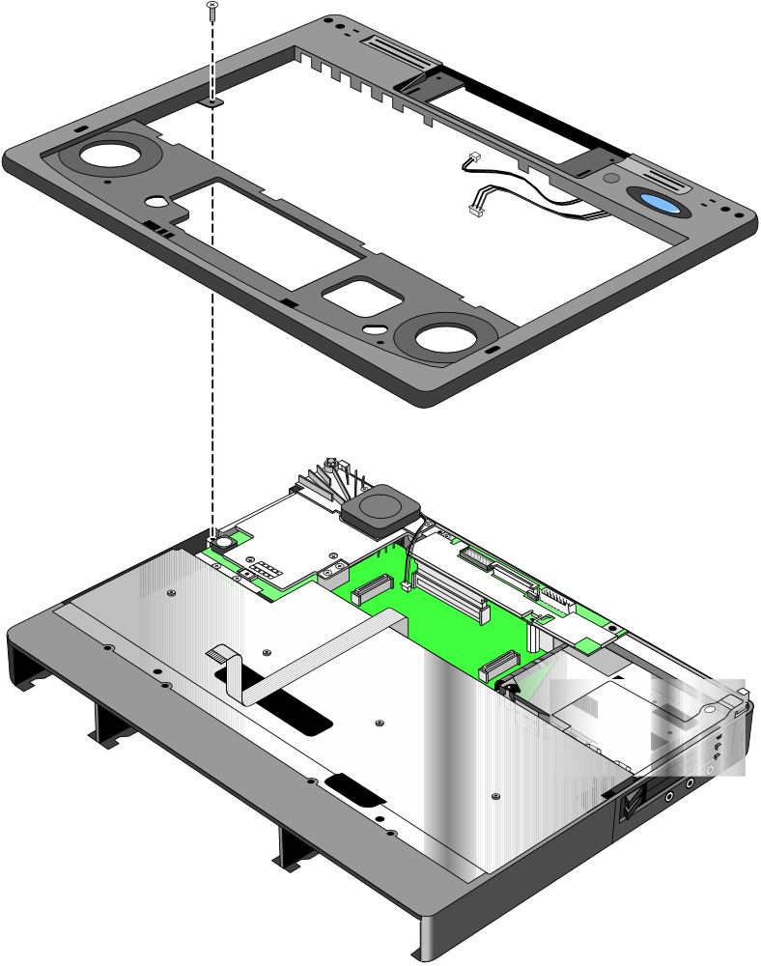
Figure 35 - Upper Chassis Case Removal
Upper Chassis Case
F1350-60915 - OB2000 & OB5700
F1320-60931 - OB5500 only
Upper Chassis Case Screw
F1320-60963
Microphone Cable
On/Suspend Button Cable

- Remove the Icon Board Screw (see Figure 36). Gently rock the Icon Board back and forth to free it from the connector.

Icon Board Screw
F1320-60963
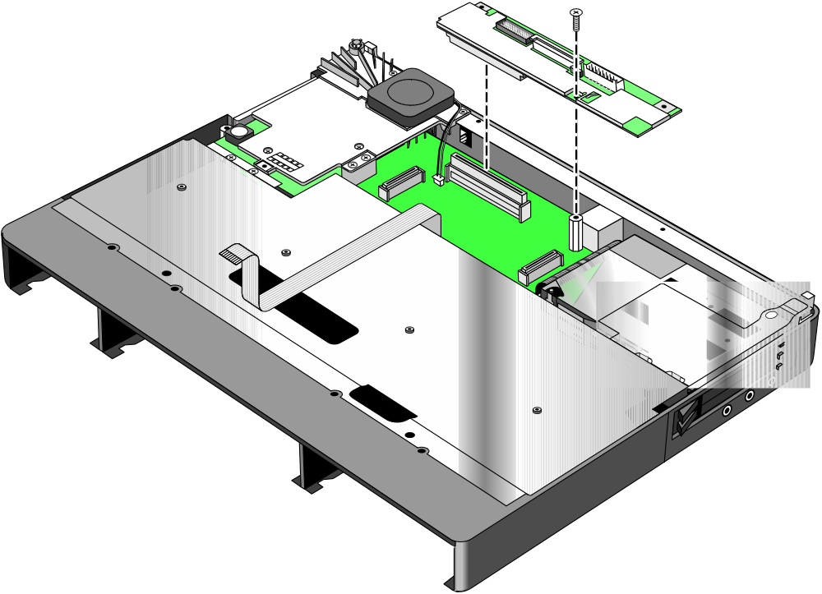
Figure 36 - Icon Board Removal
Icon Board

Replacement Procedure
- Reverse the above Removal Procedure.

CPU Module
(HP Authorized Service Providers Only)

The following table lists the various CPU modules for the OmniBook 2000, 5500, and 5700.

Table 21 - CPU Module Compatibility Matrix
CPU Module | Part Number | Exchange Part # | OB2000 | OB5500 | OB5700
100C | F1320-60901 | F1320-69001 |  | ü
120C | F1320-60902 | F1320-69002 |  | ü
133C | F1320-60903 | F1320-69003 |  | ü
150C (MMX) | F1350-60904 | F1350-69004 |  |  | ü
166C (MMX) | F1350-60905 | F1350-69005 |  |  | ü
P54C-133 | F1371-60908 | F1371-69008 | ü
P55C-133 (MMX) | F1371-60909 | F1371-69009 | ü

Required Equipment
- Small phillips screwdriver

Removal Procedure
- Exit all applications, including Windows.
- Turn the OmniBook off and remove the battery and ac adapter.
- Follow the Display Removal Procedure on page 69 and the Keyboard Removal Procedure on page 72 to remove these components.
- Remove the Upper Chassis Case Screw and disconnect the On/Suspend Button and Microphone Cables. Lift the Upper Chassis Case from the base of the unit. See Figure 35 on page 79.
5a. For the OmniBook 2000 and 5700, follow these steps:
- Remove the two CPU Screws (see Figure 37 on page 82 for the location of the screws) and disconnect the CPU Fan Cable.
- Gently rock the CPU Module back and forth to remove.
- Remove the two CPU Fan Screws and the CPU Fan (see Figure 37 for the location of the screws).
5b. For the OmniBook 5500, follow these steps:
- Remove the two Heat Spreader Screws and lift away the Heat Spreader. Refer to Figure 38 on page 83.
- Remove the one Heat Pipe Bracket Screw and lift away the Heat Bracket.
- Very carefully lift the Heat Pipe from the Keyboard Shielding Plate. Do not bend the Heat Pipe as this will decrease its effectiveness.
- Remove the two Heat Sink Screws and the four CPU Screws. Gently rock the CPU back and forth to remove.

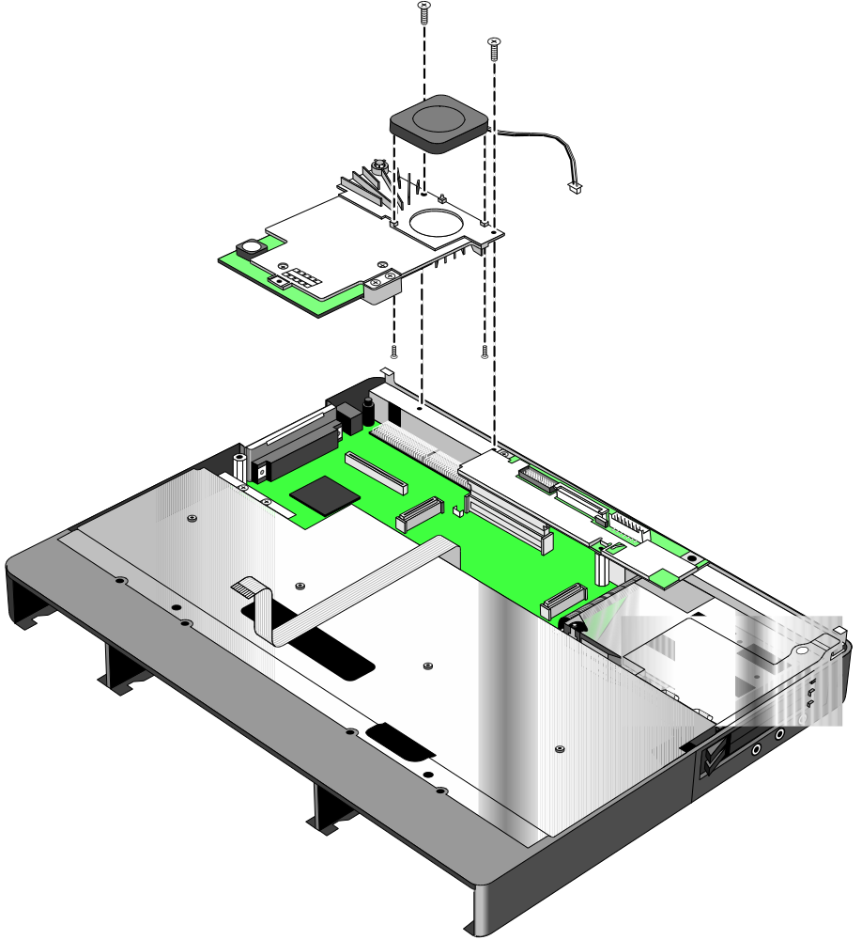
Figure 37 - CPU and CPU Fan Removal (OB2000 & OB5700 only)
CPU Fan
F1350-60906
CPU Module
CPU Screws
F1350-60927
(qty 2)
CPU Fan Screw
F1350-60925
CPU Fan Screw
F1350-60926

Heat Spreader Screw (left)
F1081-60942
Heat Pipe Bracket Screw
F1320-60963
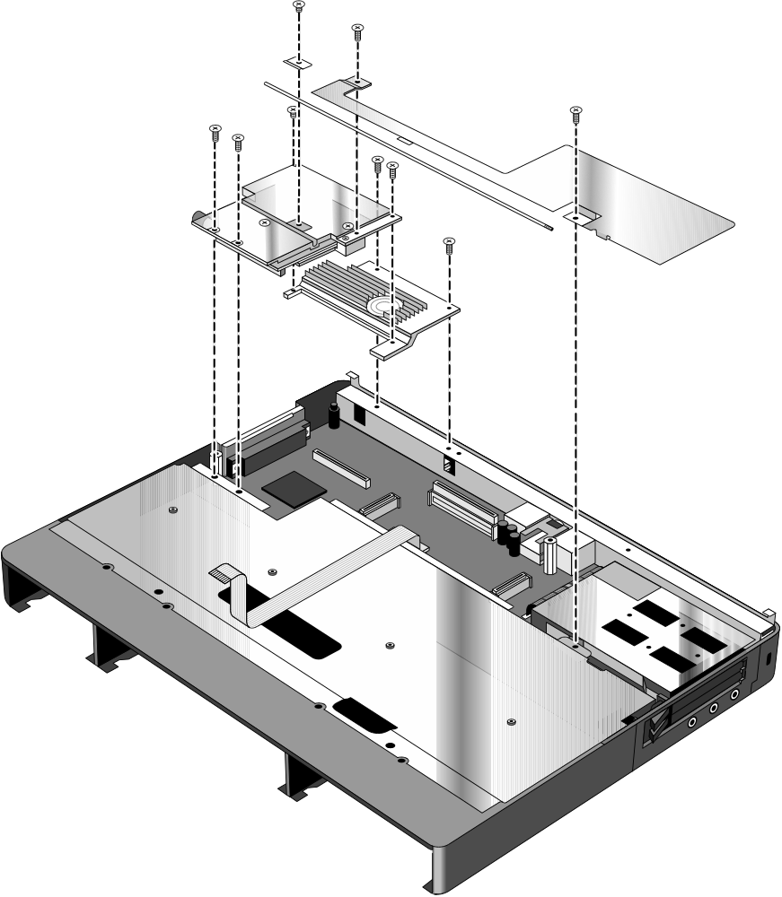
Figure 38 - CPU and Heat Spreader Removal (OB5500 only)
Heat Spreader
F1320-60921
Heat Pipe
F1320-60964
Heat Sink
F1320-60954
CPU Module
Heat Pipe Bracket
F1320-60972
CPU Screws (4)
F1320-60963
Heat Sink Screws (2)
F1350-60927
Heat Spreader Screw (right)
F1320-60963

Replacement Procedure
- Reverse the above Removal Procedure

Logic PCA Board (PCA PB-586/IO Bracket)
(HP Authorized Service Providers Only)

The OmniBook 2000 and 5700 are shipped with an electronic serial number programmed in EEPROM on the Logic PCA Board. This built-in serial number will help MIS managers in tracking assets and software configuration. Serial numbers can also be used for security and in tracking lost or stolen notebooks. The Desktop Management Interface (DMI) TopTools application shipped with the OmniBook can be used to read the serial number locally and across a network (requires HP OpenView network administration software architecture).

Programming the Electronic Serial Number
All replacement Logic PCA Boards will arrive without a serial number programmed in EEPROM. The following procedure provides the steps necessary to program the electronic serial number

- After installation of the replacement Logic PCA Board and upon reboot, the OmniBook will halt with this prompt:
INVALID ELECTRONIC SERIAL NUMBER
PRESS ANY KEY TO CONTINUE
- After a key is pressed, the OmniBook will continue a normal boot process. The HP Authorized Service Provider must program a valid serial number before the OmniBook can be shipped to the customer.
- Boot the OmniBook to the DOS command-line an run the ESN.EXE program located in the c:\omnibook\diag directory.
- The ESN program will prompt for a valid serial number.
- Enter the serial number located on the bottom of the OmniBook. Use uppercase letters to be consistent with the appearance of the serial number on the OmniBook. The ESN program will burn the serial number into EEPROM.

Overriding an Incorrect Electronic Serial Number
If an incorrect serial number is inadvertently burned into EEPROM, it can be corrected. Perform the following steps:

- Run the ESN.EXE program located in the c:\omnibook\diag directory.
- The ESN program will prompt to confirm that the serial number is incorrect. It will then generate a five (5) digit number key.
- The HP Authorized Service Provider must contact Hewlett-Packard Technical Support at this point.
- HP Technical Support will ask for a CZ authorization number, or comparable credentials, and the five (5) digit number (from step 2).
- HP Technical Support will provide a validation key to the HP Authorized Service Provider.
- Enter the validation key. This will erase the existing electronic serial number and prompt for a new number.
- Follow the above steps in Programming the Electronic Serial Number to enter the correct serial number.

Note, updating the BIOS or software on the OmniBook will not affect the electronic serial number.
The following table summarizes the different logic PCA boards for the OmniBook 2000, 5500, and 5700.

Table 22 - Logic PCA Compatibility Matrix
Logic PCA | Part Number | Exchange Part # | OB2000 | OB5500 | OB5700
PCA PT-586 with I/O Bracket | F1320-60926 | F1320-69026 |  | ü
PCA PB-586 with I/O Bracket | F1350-60901 | F1350-69001 | ü |  | ü

Required Equipment
- Small phillips screwdriver
- 5mm hexdriver

Removal Procedure
- Exit all applications, including Windows.
- Turn the OmniBook off and remove the battery, ac adapter. For the OmniBook 2000 and 5700 only, remove the Logic PCA Screw (see Figure 39 for location).

Logic PCA Screw
F1350-60923
(OB2000 & OB5700 only)
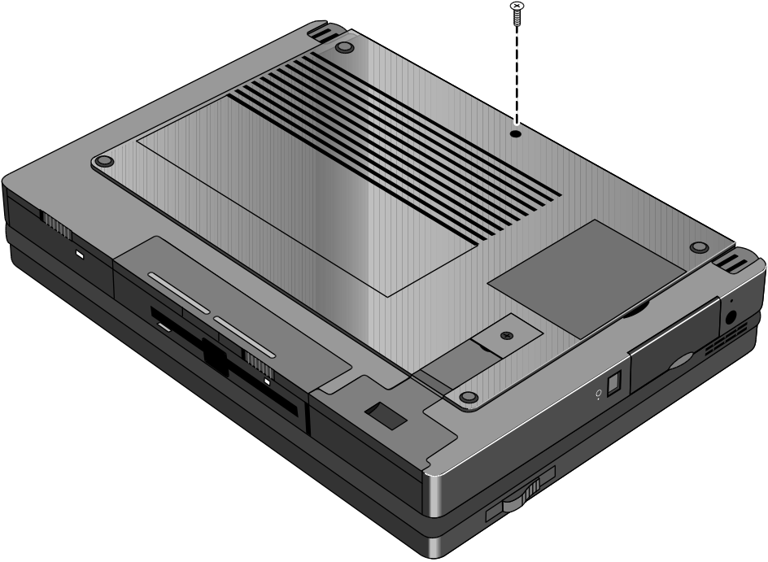
Figure 39 - Additional Screw for Logic PCA Removal

- Follow the CPU Module Removal Procedure on page 84 and the Icon Board Removal Procedure on page 77 to gain access to the Logic PCA Board.
- Now remove the Card Bus Bracket (OB2000 & OB5700 only) then the Keyboard Shielding Plate (five screws). See Figure 40 on page 86 for location of the screws.
- To remove the Logic PCA Board from the Lower Chassis Case, three screws, two standoffs, the FFC Cable T/B to M/B, and the HDD-FPC Flex must first be removed. See Figure 41 on page 87 for the location of these components. The IR Lens and Bezel are now accessible.

Caution: | Apply even pressure to both sides of the HDD FPC Flex when removing or replacing to avoid damage to the connector pins on the Logic PCA.

Card Bus Bracket Screw
F1320-60963
(qty 1)
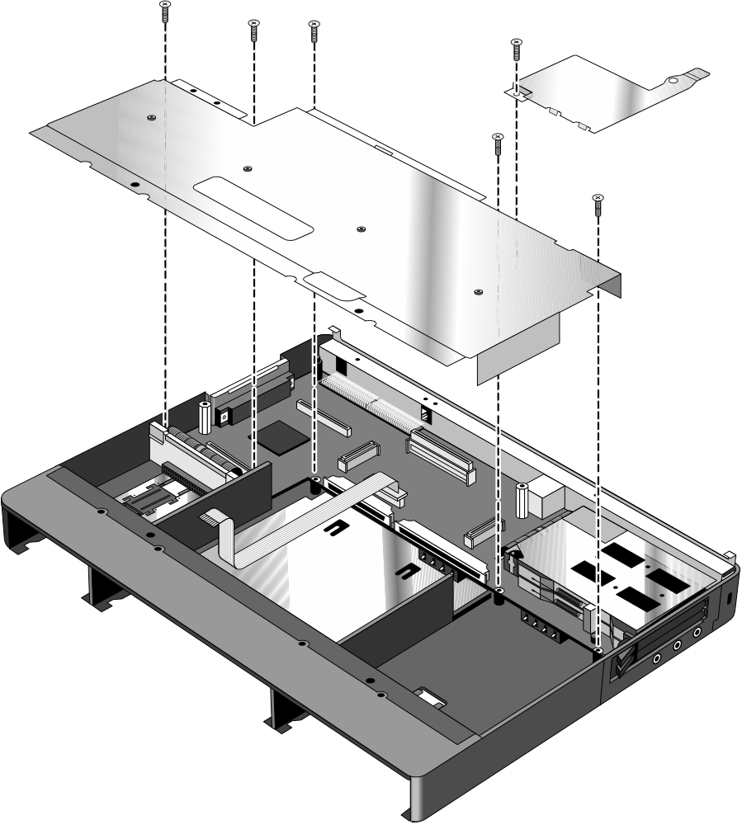
Figure 40 - Keyboard Shielding Plate Removal
Card Bus Bracket
F1350-60916
(OB2000 & OB5700 only)
Keyboard Shielding Plate
F1320-60960
Keyboard Shielding Plate Screws (qty 5)
F1350-60924

Screw
F1350-60924
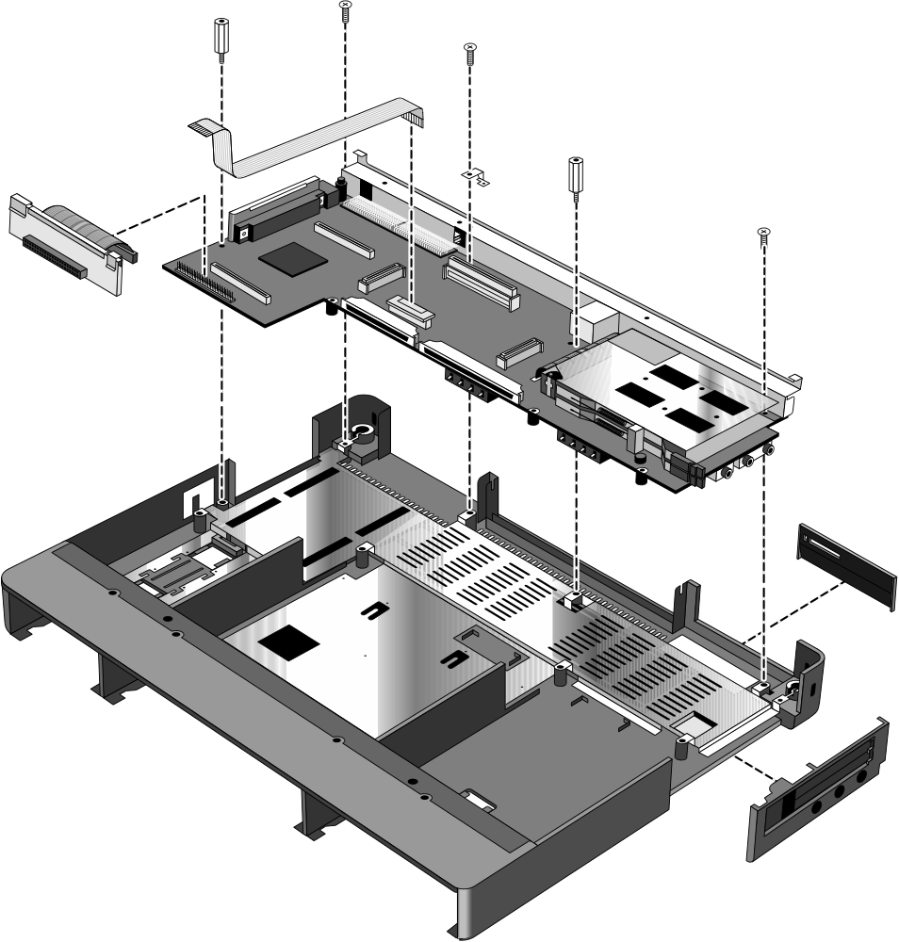
Figure 41 - Logic PCA Board Removal
Bezel
F1320-60958
Standoff
F1350-60929
Standoff
F1350-60928
Screw
F1350-60924
Dock Grounding Spring Plate
F1320-60962
FFC Cable T/B to M/B
F1320-60950
Logic PCA Board
IR Lens
F1320-60952
Lower Chassis Case

Screw
F1350-60924
HDD to FPC Flex
F1320-60961
and Bracket
F1320-60965

Replacement Procedure
- Reverse the above Removal Procedure.

Programmable Flash BIOS IC
(HP Authorized Service Providers Only)

The replacement BIOS IC will contain enough basic BIOS programming to boot the OmniBook. However, after replacing the IC, the BIOS must be reprogrammed. Hewlett-Packard prefers that the system is programmed with the latest BIOS for the respective OmniBook. The latest BIOS can be downloaded from the WWW (see Table 1 - Additional Resources on page 5).

Required Equipment
- Small phillips screwdriver
- 5mm hexdriver (OB5500 and OB5700 only)
- BIOS Insertion/Removal Tool (F1371-60904)

Removal Procedure
- Exit all applications, including Windows.
- Turn the OmniBook off and remove the battery and ac adapter.
3a. For the OmniBook 5700 and 5500, follow the Logic PCA Board Removal Procedure to gain access to the BIOS IC. Turn the Logic PCA over and proceed with step four (4) below.
3b. For the OmniBook 2000, remove the Flash BIOS Door as shown in Figure 42.

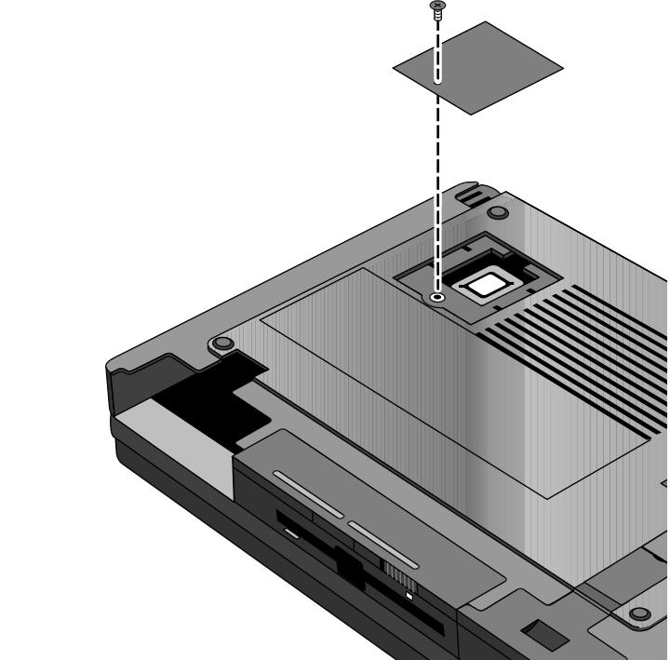
Figure 42 - Flash BIOS Door Removal
Flash BIOS Door
F1371-60901
Flash BIOS Door Screw
F1371-60902

- Use a BIOS Insertion/Removal Tool to extract the BIOS IC from the Logic PCA. See Figure 43 on page 89.

BIOS Insertion/Removal Tool
F1371-60904
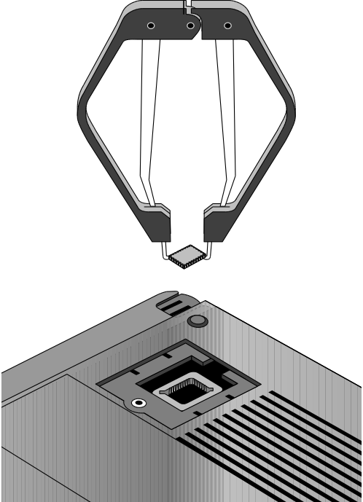
Figure 43 - Flash BIOS IC Removal
Programmable Flash BIOS IC
F1321-60907 (OB5500 only)
F1371-60903 (OB2000 & OB5700)

Replacement Procedure
- Align the Flash BIOS IC with the slot on the Logic PCA. The IC is keyed to fit correctly.
- Press down firmly on the IC to ensure a proper connection. See Figure 44.
- Replace the remainder of the OmniBook components.
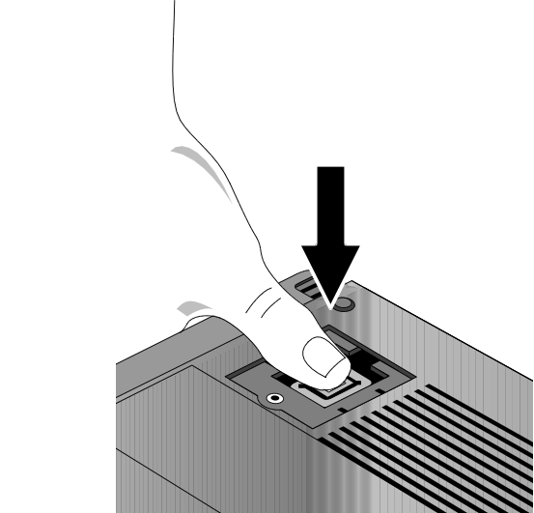
Figure 44 - Replacing the Flash BIOS IC

Video Memory (OB2000 & OB5700 Only)
(HP Authorized Service Providers Only)

Note: | Only the OmniBook 2000 and 5700 contain video memory that is replaceable. This repair procedure is not applicable for the OmniBook 5500.  Also be aware that the Video Memory Board contains only 1MB of the total 2MB of video RAM on the system. The other 1MB of video RAM is integrated with the Logic PCA Board. Therefore, to replace all of the video RAM, the Logic PCA Board must be replaced (the replacement logic PCA will contain a new video RAM board).

Required Equipment
- Small phillips screwdriver
- 5mm hexdriver

Removal Procedure
- Exit all applications, including Windows.
- Turn the OmniBook off and remove the battery and ac adapter.
- Follow the Logic PCA Board Removal Procedure on page 84 to gain access to the Video Memory.
- Remove the one necessary screw on the Logic PCA Board. See Figure 45.
- Rock the Video Memory Board gently back and forth to remove.

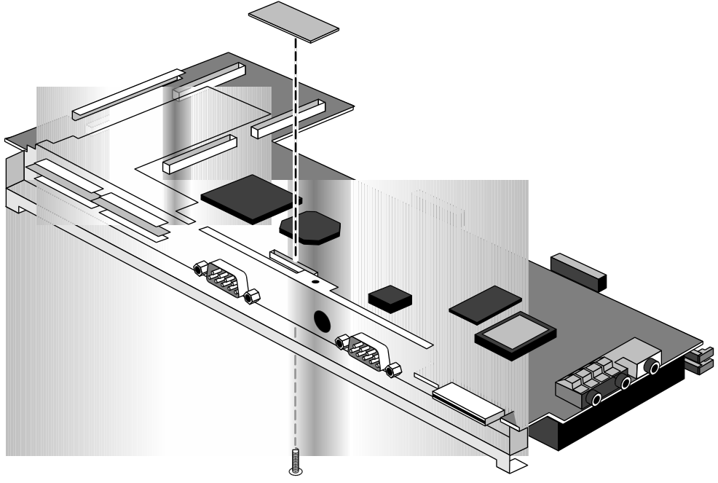
Figure 45 - Video Memory Removal
Video Memory Board
F1350-60922
Video RAM Screw
F1320-60963

Replacement Procedure
- Reverse the above Removal Procedure.

Other Components and Accessories
(HP Authorized Service Providers Only)

The below table lists additional replaceable components and the disassembly procedure(s) necessary to gain access to each. The accessories require a unit exchange (no repairable parts), unless otherwise indicated.

Table 23 - Other Repairable Components and Accessories
Component | Disassembly Procedure(s)/page# | Equipment | Special Notes
Bezel | Logic PCA Board - page 84 | Small phillips screwdriver, 5mm hexdriver
Card Bus Bracket | Display - page 69  Keyboard - page 72 | Small phillips screwdriver | The Upper Chassis must also be removed.
CD-ROM Drive |  |  | The CD-ROM Drive contains no repairable components. A unit exchange is required.
CPU Fan | CPU Module - page 81 | Small phillips screwdriver
DC Power Supply Board | Keyboard - page 72 | Small phillips screwdriver
Dock Grounding Spring Plate | Icon Board - page 77 | Small phillips screwdriver | Remove the one screw holding the Spring in place.
Docking System |  |  | The Docking System (F1189) does contain repairable components. Refer to the F1189-90008 manual for instructions.
EMI Spring for LCD Hinge | Display - page 69  Keyboard - page 72 | Small phillips screwdriver | The Upper Chassis must also be removed. The Hinge simply slips out of its socket.
FFC Cable T/B to M/B | Keyboard - page 72 | Small phillips screwdriver
HDD PCB Bracket | Display - page 69  Keyboard - page 72 | Small phillips screwdriver | The Upper Chassis, Keyboard Shielding Plate, and Card Bus Bracket must also be removed.
HDD-FPC Flex | Display - page 69  Keyboard - page 72 | Small phillips screwdriver | The Upper Chassis, Keyboard Shielding Plate, and Card Bus Bracket must also be removed.
Heat Pipe | CPU Module - page 81 | Small phillips screwdriver
Heat Pipe Bracket | CPU Module - page 81 | Small phillips screwdriver
Heat Pipe Spreader | CPU Module - page 81 | Small phillips screwdriver
Heat Sink | CPU Module - page 81 | Small phillips screwdriver
I/O Bracket Grounding Clips | Logic PCA Board - page 84 | Small phillips screwdriver, 5mm hexdriver | The Clips easily slide off either side of the Logic PCA Board.
Icon Assembly | Display - page 69 | Small phillips screwdriver | The Display does not need to be completely removed.
IR Lens | Logic PCA Board - page 84 | Small phillips screwdriver, 5mm hexdriver
Keyboard Shielding Plate | Display - page 69  Keyboard - page 72 | Small phillips screwdriver | The Upper Chassis and Card Bus Bracket must also be removed.
Lower Chassis Case | Logic PCA Board - page 84 | Small phillips screwdriver, 5mm hexdriver
Palmrest Assembly | Keyboard - page 72 | Small phillips screwdriver | The Keyboard does not need to be completely removed.
Port Replicator |  |  | The Port Replicator contains no repairable components. A unit exchange is required.
Sub Battery | Keyboard - page 72 | Small phillips screwdriver | The Sub Battery is accessible once the Palmrest is lifted up.
Upper Chassis Case | Display - page 69  Keyboard - page 72 | Small phillips screwdriver | Remove the one screw and disconnect the On/Suspend and Microphone Cables.

Appendix A - Technical Specifications

Mass Storage Specifications

Hard Disk Drive
The hard disk drive can be removed by the user for easy upgrades.

Hard drive manufacturers are subject to change without notice.

Table 24 - Hard Disk Drive Specifications
 | 810-million-byte | 1.35-billion-byte | 1.44-billion-byte | 2.1-billion-byte | 3.1-billion-byte
Manufacturer | Toshiba | Toshiba | Toshiba | Toshiba | Toshiba
Interface | ATA2 | ATA2 | ATA2 /ATA3 | ATA2 /ATA3 | ATA2 /ATA3
Recording Method | PRML (Partial Response Maximum likelihood) | PRML (Partial Response Maximum likelihood) | PRML (Partial Response Maximum likelihood) | PRML (Partial Response Maximum likelihood) | PRML (Partial Response Maximum likelihood)
Heads | Peak Detect | MR (Magneto Resistive) | MR (Magneto Resistive) | MR (Magneto Resistive) | MR (Magneto Resistive)
Average access (read) | 13 ms | 13 ms | 13 ms | 13 ms | 13 ms
Track to track seek | 3 ms | 3 ms | 3 ms | 3 ms | 3 ms
Full Track | 25 ms | 25 ms | 25 ms | 25 ms | 25 ms
Average latency | 7.14 ms | 7.14 ms | 7.14 ms | 7.4 ms | 6.18 ms
Rotational speed | 4200 rev/m | 4200 rev/m | 4200 rev/m | 4200 rev/m | 4852 rev/m
Media Transfer rate | 24.7 (inner), 44.9 (Outer) Mbits/sec | 38.1 (inner), 54.8 (Outer) Mbits/sec | 38.6 (inner), 69.8 (Outer) Mbits/sec | 38.6 (inner), 69.8 (Outer) Mbits/sec | 43.8 (inner), 68.9 (Outer) Mbits/sec
Buffer to host | 16.6 Mbytes/sec | 16.6 Mbytes/sec | 16.6 Mbytes/sec | 16.6 Mbytes/sec | 16.6 Mbytes/sec
Buffer size | 128KB (read and write segmented buffer) | 128KB (read and write segmented buffer) | 128KB (read and write segmented buffer) | 128KB (read and write segmented buffer) | 128KB (read and write segmented buffer)
Spindle start time | 5 sec (typical) | 5 sec (typical) | 5 sec (typical) | 5 sec (typical) | 5 sec (typical)
Reliability:
MTBF: Power-on Hours | 300,000 hours | 300,000 hours | 300,000 hours | 300,000 hours | 300,000 hours
Unrecoverable errors | 1.0E-13 bits transfer | 1.0E-13 bits transfer | 1.0E-13 bits transfer | 1.0E-13 bits transfer | 1.0E-13 bits transfer
Configuration:
Sector Size | 512 Bytes | 512 Bytes | 512 Bytes | 512 Bytes | 512 Bytes
User Cylinders | 2,920 | 3,650 | 5,160 | 5,160 | 5,020
Data Heads | 6 | 6 | 4 | 6 | 10
Disks | 3 | 3 | 2 | 3 | 5

Floppy Disk Drive
The floppy disk drive can either be placed in the center bay slot or connected to the parallel port. It is hot-swappable and is configured as drive A by default.

Floppy disk drive manufacturers are subject to change without notice.

Table 25 - Floppy Disk Drive Specifications
 | 3.5-inch Floppy Drive
Manufacturer | TEAC
Data Capacity | 1.44MB (formatted)  2M (unformatted) | 724KB (formatted)  1M (unformatted)
Data Transfer Rate | 500k bits/sec | 250k bits/sec
Disk Rotational Speed | 300rpm
Track Density | 135tpi
Cylinders | 80
Track-to-track Time | 3ms
Average Seek Time | 94ms
Start Time | 480ms
Average latency | 100ms
Mean Time Between Failures | 30,000 hours
Error Rate
Soft (recoverable) | 1 or less per 10⁹ bits read
Hard (unrecoverable) | 1 or less per 10¹² bits read
Seek | 1 or less per 10⁶ bits read

CD-ROM Drive
The CD-ROM Drive is an accessory to the OmniBook. It is designed to operate only in the center bay.

CD-ROM drive manufacturers are subject to change without notice.

Table 26 - CD-ROM Drive Specifications
 | 6x CD-ROM Drive | 10x CD-ROM Drive
Manufacturer | Toshiba | Toshiba
Transfer Rate | 900K sustained | 1710 KB/sec max
Buffer | 128K | 128K
Access Speed | 190ms | 150ms
Start-up Time | 2.3 s (6x) | 2.3 s (10x)
Seek Time | 160ms | 130ms
Modes | CDROM (Mode 1&2), Photo CD, CD Plus, CDXA, CD-I, Multisession | CDROM (Mode 1&2), Photo CD, CD Plus, CDXA, CD-I, Multisession

System Resources

Below are default values for system resources. To see other, non-default possibilities, use the System Configuration Utility (SCU) which lists port and audio device configurations in the Input/Output menu. For additional information on configuring system resources, refer to the System Configuration Utility section on page 45.

The tables in this section show typical resource usage as set up by the OmniBook BIOS. Plug-and-play operating systems, drivers, and SCU settings may change some of the entries.

System Interrupts
The following tables list the available interrupts for the OmniBook 2000, 5500, and 5700.

Table 27 - System Interrupts for the OmniBook 2000 and 5700
0 | System timer
1 | Keyboard
2 | Redirect IRQ 9
3 | COM2 (IR) and COM4 (free in Win95 when docked)
4 | COM1 and COM3 (serial port)
5 | Crystal sound
6 | Floppy drive
7 | LPT1 (parallel port)
8 | Real-time clock
9 | MIDI
10 | PCI-type interrupt: CardBus (undocked) / SCSI (docked)
11 | Free
12 | Mouse
13 | Coprocessor
14 | Internal hard disk (primary IDE controller)
15 | Internal CD-ROM (secondary IDE controller)

Table 28 - System Interrupts for the OmniBook 5500
0 | System timer
1 | Keyboard
2 | Redirect IRQ 9
3 | COM2 (serial IR) and COM4 (free in Win95 when docked)
4 | COM1 and COM3 (serial port)
5 | Crystal sound
6 | Floppy drive
7 | LPT1 (parallel port)
8 | Real-time clock
9 | MIDI
10 | Fast IR (undocked)/AMD SCSI (docked)
11 | Free
12 | Mouse
13 | Coprocessor
14 | Internal hard disk (primary IDE controller)
15 | Internal CD-ROM (secondary IDE controller, free if no internal CD)

System Memory
The following tables list the memory maps for the OmniBook 2000, 5500, and 5700.

Table 29 - System Memory Map for the OmniBook 2000 and 5700
C0000-CAFFF | Chips & Technologies video BIOS
CB000-CBFFF | Enhanced parallel port BIOS
CC000-CFFFF | Free
D0000-D1FFF | TI1131 PC Card Controller
D2000-E7FFF | Free
E8000-FFFFF | Plug-and play ISA, PCI, and System BIOS

Table 30 - System Memory Map for the OmniBook 5500
C0000-C9FFF | Chips & Technologies video BIOS
CA000-CAFFF | Enhanced parallel port BIOS
CB000-CFFFF | Free
D0000-D1FFF | Cirrus Logic PC Card Controller
D2000-E7FFF | Free
E8000-EDFFF | Plug-and play BIOS
EE000-EFFFF | Plug-and-Play ISA
F0000-FFFFF | System BIOS

System Input/Output Addresses
The following tables list the available I/O addresses for the OmniBook 2000, 5500, and 5700.

Table 31 - System I/O Addresses for the OmniBook 2000 and 5700
15C-15D | Super I/O in Docking System
170-178 | Secondary HDD controller (internal CD-ROM)
1F0-1F7 | Internal hard disk
200-201 | Joystick
220-22F | Crystal sound
2F8-2FF | COM2 (infrared port)
330-331 | MPU 401 (MIDI)
378-37A | LPT1 (printer port)
388-38B | Sound
3B0-3BB | VGA adapter
3C0-3DF | VGA adapter
3E0-3E1 | PC card bridge on PCI
3F0-3F5 | Floppy controller
3F6 | Primary HDD controller
3F8-3FF | COM1 (serial port)
400-47F | SCSI host controller
3000-300F | IDE but mastering registers
6000-6FFF | PC CardBus
8000-8FFF | PC CardBus

Table 32 - System I/O Addresses for the OmniBook 5500
170-178 | Secondary HDD controller (internal CD-ROM)
1F0-1F7 | Internal hard disk
220-22F | Crystal sound
2F8-2FF | COM2 (infrared port)
330-331 | MPU 401 (MIDI)
378-37A | LPT1 (printer port)
388 | Sound
3C0-3DF | VGA adapter
3E0-3E1 | PC card bridge on PCI
3F0-3F5 | Floppy controller
3F6 | Primary HDD controller
3F8-3FF | COM1 (serial port)
3000-33FF | VGA on PCI
3400-347F | SCSI on PCI
3E0H-3E1H | PC Card on ISA

DMA Channels
The following tables lists the available DMA channels for the OmniBook 2000, 5500, and 5700.

Table 33 - DMA Channels for the OmniBook 2000 and 5700
0 | Sound record
1 | Sound playback
2 | Floppy drive
3 | Fast IR
4 | DMA controller
5 | Free
6 | Free
7 | Free

Table 34 - DMA Channels for the OmniBook 5500
0 | Free
1 | Sound playback
2 | Floppy drive
3 | Sound record
4 | Free
5 | Free
6 | Free
7 | Free

Appendix B - Hewlett-Packard Password Removal Policy

If the user forgets the system password, there is a master password that will unlock the OmniBook. The user calls Technical Support to determine this master password as follows:
- Support will tell the user the keys to type at the password entry screen: [alt][shft][f10]
- The OmniBook generates and displays an encoded master password. This is displayed under the normal password entry area. At this point, this is the only password that will unlock the OmniBook unless the user presses [ESC] to remove the encoded master from the password entry screen. Then the user's stored password can be entered.
- The user reads the encoded master password to Support.
- Support runs a program that decodes the encoded password, and reads the decoded password (alphanumeric) to the user.
- The user types in the decoded password.
- OmniBook decodes the encoded master password it generated and compares it to the decoded password typed in by the user.
- If the two passwords match, the OmniBook is unlocked. The forgotten password is automatically erased. Support can then guide the user through the process of entering a new password.
- If the two passwords do not match, the previous sequence must be repeated until the user correctly enters a master password.
The encoded master password is an eight-character alphanumeric sequence that the OmniBook generates at random every time the appropriate keys are pressed in the password entry screen. Because it is generated randomly, a master password can only be used to unlock the OmniBook once. If the user forgets the password at another time, it will require another call to Support. (If the user presses the appropriate keys by mistake, pressing [ESC] will allow entering the stored password.)
The password descramble programs for the HP OmniBook Notebook PCs are protected as HP Company Private information. They may not be copied, backed-up, printed or distributed. There are only six official copies of each program.
In addition to the program being protected, its use is also controlled. Hewlett-Packard and authorized support providers must ensure with written evidence that the OmniBook that is being "descrambled" is actually in the hands of the unit's actual and current owner. This requires a sales receipt showing the unit serial number and owner's name, or a written statement from the owner attesting that he or she is the owner of the unit. The statement can be a fax copy of the document. The fact that the unit is in the hands of an HP representative on behalf of the customer is not evidence of ownership. In addition, HP will not descramble a unit for any non-owner, even if it involves law enforcement agencies. If you receive such a request, you should notify management and HP Corporate Legal immediately. (These requests may require a court order prior to our participation.)
Further, you must log the name, serial number and date of the running of the descramble program, and file the written backup with the log. The log and backup are subject to standard record retention process and review.
The final issue relating to descramble of passwords is that HP cannot provide information to users that would assist them in improperly descrambling a password and opening a unit.

Appendix C - Hewlett-Packard TFT Display Quality Statement

TFT display manufacturing is a high precision but imperfect technology and manufacturers cannot currently produce large displays that are cosmetically perfect. Most, if not all, TFT displays will exhibit some level of cosmetic imperfection. These cosmetic imperfections may be visible to the customer under varying display conditions and can appear as bright, dim or dark spots. This issue is common across all vendors supplying TFT displays in their products and is not specific to the HP OmniBook display.

HP OmniBook TFT displays meet or exceed all TFT manufacturers’ standards for cosmetic quality of TFT displays. HP does not warrant that the displays will be free of cosmetic imperfections. TFT displays may have a small number of cosmetic imperfections and still conform to the display manufacturers’ cosmetic quality specifications.

Here are some guidelines to use in determining what action to take on customers’ complaint of cosmetic imperfection in their TFT display:

- The unit should be viewed in the customer's normal operating condition.
This means if the customer uses the unit predominately in DOS, or Windows, or in some other application or combination of applications, that is where the determination shall be made. Self test is not a normal operating condition and is not a sufficient tool to interpret display quality.

- In the customer's normal operating mode:
- If 4 or more variant pixels appear clustered in the area approximated by a thumbprint on the display surface, then the display should be considered for replacement.
- On OmniBook 4000CT models, if more than 30 total pixels anywhere on the display are bad, then the display should be considered for replacement. On all other OmniBook models, if more than 15 total pixels anywhere on the display are bad, then the display should be considered for replacement.

These are the only conditions in this guideline that may call for a replacement due to a defect in material or workmanship based on the HP Limited Warranty Statement.

- If a display is considered for replacement, it should be clear to the customer that cosmetic variations on the replacement display may also exist, and may require the customer to use a work-around to obscure the cosmetic imperfection.

- Customers with cosmetic-based complaints only, that do not conform to the above conditions and tests will not normally be considered for display replacement. It will be left to the judgment of the HP-responsible person working with the customer, to identify work-arounds that are reasonable and appropriate for the individual customer. Customers who must have a more perfect display solution should consider switching to an OmniBook with a DSTN display.

We expect over time that the industry will continue to improve in its ability to produce displays with fewer inherent cosmetic imperfections and we will adjust our HP guidelines as the improvements are implemented.
Appendix D - Assembly Sub-Component Breakout

The following pages contain a breakout of various sub-components of the major replaceable assemblies for the OmniBook 2000, 5500, and 5700. The chart indicates whether or not the sub-component is included with the replacement assembly. For example, a replacement hard disk drive does not include a hard drive plastic kit. The plastic kit from the defective hard drive may be reused or a new plastic kit may be ordered separately.

This chart is indented to aid in determining which components need to be ordered when replacing an assembly of the OmniBook. However, in the continuing effort to improve the exchange process, this information may change without notice.

Assembly |  | OmniBook |  |  |  | Sub-component(s) |  |  |  | Included
 |  | 2000 | 5500 | 5700 |  |  |  | (y/n)
CPU Module
CPU Module/100C | F1320-60901 |  | ü |  | Heat Sink |  | F1320-60954 |  | No
CPU Module/120C | F1320-60902 |  | ü |  | Heat Sink |  | F1320-60954 |  | No
CPU Module/133C | F1320-60903 |  | ü |  | Heat Sink |  | F1320-60954 |  | No
CPU Module/150C | F1350-60904 |  |  | ü | CPU Fan |  | F1350-60906 |  | No
 |  |  |  |  | EMI Spring for LCD Hinge |  | F1350-60913 |  | Yes
CPU Module/166C | F1350-60905 |  |  | ü | CPU Fan |  | F1350-60906 |  | No
 |  |  |  |  | EMI Spring for LCD Hinge |  | F1350-60913 |  | Yes
CPU Module/P54C-133 | F1371-60908 | ü |  |  | CPU Fan |  | F1350-60906 |  | No
 |  |  |  |  | EMI Spring for LCD Hinge |  | F1350-60913 |  | Yes
CPU Module/P55C-133 (MMX) | F1371-60909 | ü |  |  | CPU Fan |  | F1350-60906 |  | No
 |  |  |  |  | EMI Spring for LCD Hinge |  | F1350-60913 |  | Yes
Display - LCD Assembly
LCD Assy - 10.4” TFT/S | F1320-60904 |  | ü |  | Disp Panel Plastic 10.4” TFT |  | F1320-60934 |  | Yes
 |  |  |  |  | Disp Cover Plastic 10.4” TFT |  | F1320-60935 |  | Yes
 |  |  |  |  | Display Hook- Left |  | F1320-60938 |  | Yes
 |  |  |  |  | Display Hook - Right |  | F1320-60939 |  | Yes
 |  |  |  |  | Display Hook - Button (2) |  | F1320-60940 |  | Yes
 |  |  |  |  | Display Contrast Btn (2) |  | F1371-60917 |  | Yes
 |  |  |  |  | Flex Cable 10.4” LCD |  | F1320-60941 |  | Yes
 |  |  |  |  | Label - HP OmniBook |  | F1065-80005 |  | Yes
 |  |  |  |  | Display Label 5500CT |  | F1320-60970 |  | Yes
 |  |  |  |  | Label - Intel Pentium |  | 5182-5113 |  | Yes
 |  |  |  |  | Label - Win95 |  | 7121-7353 |  | Yes
 |  |  |  |  | Top Rubber Pad (2) |  | 5183-2257 |  | Yes
 |  |  |  |  | Bottom Rubber Pad (2) |  | 5183-2258 |  | Yes
LCD Assy - 11.3” DSTN/S | F1320-60905 |  | ü |  | Disp Panel Plastic 11.3” DSTN |  | F1320-60936 |  | Yes
 |  |  |  |  | Disp Cover Plastic 11.3” DSTN |  | F1320-60937 |  | Yes
 |  |  |  |  | Display Hook- Left |  | F1320-60938 |  | Yes
 |  |  |  |  | Display Hook - Right |  | F1320-60939 |  | Yes
 |  |  |  |  | Display Hook - Button (2) |  | F1320-60940 |  | Yes
 |  |  |  |  | Display Contrast Btn (2) |  | F1371-60917 |  | Yes
 |  |  |  |  | Flex Cable 11.3” LCD |  | F1320-60942 |  | Yes
 |  |  |  |  | Label - HP OmniBook |  | F1065-80005 |  | Yes
 |  |  |  |  | Display Label 5500CS |  | F1320-60969 |  | Yes
 |  |  |  |  | Label - Intel Pentium |  | 5182-5113 |  | Yes
 |  |  |  |  | Label - Win95 |  | 7121-7353 |  | Yes
 |  |  |  |  | Top Rubber Pad (2) |  | 5183-2257 |  | Yes
 |  |  |  |  | Bottom Rubber Pad (2) |  | 5183-2258 |  | Yes
LCD Assy - 12.1” TFT/S | F1320-60906 | ü | ü | ü | Disp Panel Plastic 12.1” TFT |  | F1320-60932 |  | Yes
 |  |  |  |  | Disp Cover Plastic 12.1” TFT |  | F1320-60933 |  | Yes
 |  |  |  |  | Display Hook- Left |  | F1320-60938 |  | Yes
 |  |  |  |  | Display Hook - Right |  | F1320-60939 |  | Yes
 |  |  |  |  | Display Hook - Button (2) |  | F1320-60940 |  | Yes
 |  |  |  |  | Display Contrast Btn (1) |  | F1371-60917 |  | Yes
 |  |  |  |  | Flex Cable 12.1” LCD |  | F1320-60943 |  | Yes
 |  |  |  |  | Label - HP OmniBook |  | F1065-80005 |  | Yes
 |  |  |  |  | Display Label |  | see footnote |  | No
 |  |  |  |  | Label - Intel |  | see footnote |  | No
 |  |  |  |  | Label - Win95 |  | 7121-7353 |  | Yes
 |  |  |  |  | Top Rubber Pad (2) |  | 5183-2257 |  | Yes
 |  |  |  |  | Bottom Rubber Pad (2) |  | 5183-2258 |  | Yes
LCD Assy /SMG 12.1” TFT/S | F1320-60994 | ü | ü | ü | Disp Panel Plastic /SMG 12.1” TFT |  | F1320-60996 |  | Yes
 |  |  |  |  | Disp Cover Plastic /SMG 12.1” TFT |  | F1320-60995 |  | Yes
 |  |  |  |  | Display Hook- Left |  | F1320-60938 |  | Yes
 |  |  |  |  | Display Hook - Right |  | F1320-60939 |  | Yes
 |  |  |  |  | Display Hook - Button (2) |  | F1320-60940 |  | Yes
 |  |  |  |  | Display Contrast Btn (1) |  | F1371-60917 |  | Yes
 |  |  |  |  | Flex Cable 12.1” /SMG LCD |  | F1320-60997 |  | Yes
 |  |  |  |  | Label - HP OmniBook |  | F1065-80005 |  | Yes
 |  |  |  |  | Display Label |  | see footnoteError: Reference source not found |  | No
 |  |  |  |  | Label - Intel |  | see footnoteError: Reference source not found |  | No
 |  |  |  |  | Label - Win95 |  | 7121-7353 |  | Yes
 |  |  |  |  | Top Rubber Pad (2) |  | 5183-2257 |  | Yes
 |  |  |  |  | Bottom Rubber Pad (2) |  | 5183-2258 |  | Yes
LCD Assy 12.1” DSTN | F1371-60906 | ü |  |  | Disp Panel Plastic 12.1” DSTN |  | F1371-60914 |  | Yes
 |  |  |  |  | Disp Cover Plastic 12.1” DSTN |  | F1371-60915 |  | Yes
 |  |  |  |  | Display Hook- Left |  | F1320-60938 |  | Yes
 |  |  |  |  | Display Hook - Right |  | F1320-60939 |  | Yes
 |  |  |  |  | Display Hook - Button (2) |  | F1320-60940 |  | Yes
 |  |  |  |  | Display Contrast Btn (2) |  | F1371-60917 |  | Yes
 |  |  |  |  | Cable 12.1” DSTN |  | F1371-60916 |  | Yes
 |  |  |  |  | Label - HP OmniBook |  | F1065-80005 |  | Yes
 |  |  |  |  | Display Label 2000CS |  | F1371-60913 |  | No
 |  |  |  |  | Label - Intel Pentium |  | 5182-5113 |  | No
 |  |  |  |  | Label - Win95 |  | 7121-7353 |  | Yes
 |  |  |  |  | Top Rubber Pad (2) |  | 5183-2257 |  | Yes
 |  |  |  |  | Bottom Rubber Pad (2) |  | 5183-2258 |  | Yes
LCD Assy 12.1” TFT/X | F1350-60902 |  |  | ü | Disp Panel Plastic 12.1” TFT |  | F1320-60932 |  | Yes
 |  |  |  |  | Disp Cover Plastic 12.1” TFT |  | F1320-60933 |  | Yes
 |  |  |  |  | Display Hook- Left |  | F1320-60938 |  | Yes
 |  |  |  |  | Display Hook - Right |  | F1320-60939 |  | Yes
 |  |  |  |  | Display Hook - Button (2) |  | F1320-60940 |  | Yes
 |  |  |  |  | Display Contrast Btn (1) |  | F1371-60917 |  | Yes
 |  |  |  |  | Cable 12.1” XGA |  | F1350-60919 |  | Yes
 |  |  |  |  | Label - HP OmniBook |  | F1065-80005 |  | Yes
 |  |  |  |  | Display Label 5700CTX |  | F1350-60918 |  | No
 |  |  |  |  | Label - Intel MMX |  | 7121-7455 |  | No
 |  |  |  |  | Label - Win95 |  | 7121-7353 |  | Yes
 |  |  |  |  | Top Rubber Pad (2) |  | 5183-2257 |  | Yes
 |  |  |  |  | Bottom Rubber Pad (2) |  | 5183-2258 |  | Yes
Display Panel Plastic
Display Panel Plastic 12.1” TFT | F1320-60932 | ü | ü | ü | Label - Win95 |  | 7121-7353 |  | No
 |  |  |  |  | Display Label |  | see footnoteError: Reference source not found |  | No
 |  |  |  |  | Label - Intel |  | see footnoteError: Reference source not found |  | No
 |  |  |  |  | Display Contrast Btn (1) |  | F1371-60917 |  | No
 |  |  |  |  | Top Rubber Pad (2) |  | 5183-2257 |  | No
 |  |  |  |  | Bottom Rubber Pad (2) |  | 5183-2258 |  | No
Display Panel Plastic 10.4” TFT | F1320-60934 |  | ü |  | Label - Win95 |  | 7121-7353 |  | No
 |  |  |  |  | Display Label 5500CT |  | F1320-60970 |  | No
 |  |  |  |  | Label - Intel Pentium |  | 5182-5113 |  | No
 |  |  |  |  | Display Contrast Btn (1) |  | F1371-60917 |  | No
 |  |  |  |  | Top Rubber Pad (2) |  | 5183-2257 |  | No
 |  |  |  |  | Bottom Rubber Pad (2) |  | 5183-2258 |  | No
Display Panel Plastic 11.3” DSTN | F1320-60936 |  | ü |  | Label - Win95 |  | 7121-7353 |  | No
 |  |  |  |  | Display Label 5500CS |  | F1320-60969 |  | No
 |  |  |  |  | Label - Intel Pentium |  | 5182-5113 |  | No
 |  |  |  |  | Display Contrast Btn (2) |  | F1371-60917 |  | No
 |  |  |  |  | Top Rubber Pad (2) |  | 5183-2257 |  | No
 |  |  |  |  | Bottom Rubber Pad (2) |  | 5183-2258 |  | No
Display Panel Plastic/ SMG 12.1” TFT | F1320-60996 | ü | ü | ü | Label - Win95 |  | 7121-7353 |  | No
 |  |  |  |  | Display Label |  | see footnoteError: Reference source not found |  | No
 |  |  |  |  | Label - Intel |  | see footnoteError: Reference source not found |  | No
 |  |  |  |  | Display Contrast Btn (1) |  | F1371-60917 |  | No
 |  |  |  |  | Top Rubber Pad (2) |  | 5183-2257 |  | No
 |  |  |  |  | Bottom Rubber Pad (2) |  | 5183-2258 |  | No
Display Panel Plastic 12.1” DSTN | F1371-60914 | ü |  |  | Label - Win95 |  | 7121-7353 |  | No
 |  |  |  |  | Display Label 2000CS |  | F1371-60913 |  | No
 |  |  |  |  | Label - Intel |  | see footnoteError: Reference source not found |  | No
 |  |  |  |  | Display Contrast Btn (1) |  | F1371-60917 |  | No
 |  |  |  |  | Top Rubber Pad (2) |  | 5183-2257 |  | No
 |  |  |  |  | Bottom Rubber Pad (2) |  | 5183-2258 |  | No
Display Cover Plastic
Display Cover Plastic 12.1” TFT | F1320-60933 | ü | ü | ü | Label - HP OmniBook |  | F1065-80005 |  | No
 |  |  |  |  | Display Hook Button (2) |  | F1320-60940 |  | No
Display Cover Plastic 10.4” TFT | F1320-60935 |  | ü |  | Label - HP OmniBook |  | F1065-80005 |  | No
 |  |  |  |  | Display Hook Button (2) |  | F1320-60940 |  | No
Display Cover Plastic 11.3” DSTN | F1320-60937 |  | ü |  | Label - HP OmniBook |  | F1065-80005 |  | No
 |  |  |  |  | Display Hook Button (2) |  | F1320-60940 |  | No
Display Cover Plastic/ SMG 12.1” TFT | F1320-60995 | ü | ü | ü | Label - HP OmniBook |  | F1065-80005 |  | No
 |  |  |  |  | Display Hook Button (2) |  | F1320-60940 |  | No
Display Cover Plastic 12.1” DSTN | F1371-60915 | ü |  |  | Label - HP OmniBook |  | F1065-80005 |  | No
 |  |  |  |  | Display Hook Button (2) |  | F1320-60940 |  | No
Hard Disk Drive
HDD Drive 810MB | F1191-60901 |  | ü |  | HDD Plastic Kit |  | F1320-60947 |  | No
HDD Drive 1.35GB | F1192-60901 |  | ü |  | HDD Plastic Kit |  | F1320-60947 |  | No
HDD Drive 1.44GB | F1375-60901 | ü |  |  | HDD Plastic Kit |  | F1350-60920 |  | No
HDD Drive 2.1GB | F1339-60901 | ü |  | ü | HDD Plastic Kit |  | F1350-60920 |  | No
HDD Drive 3.1GB | F1348-60901 |  |  | ü | HDD Plastic Kit |  | F1350-60920 |  | No
HDD Plastic Kit
HDD Plastic Kit | F1320-60947 |  | ü |  | HDD Kit Screws (4) |  | n/a |  | Yes
HDD Plastic Kit | F1350-60920 | ü |  | ü | HDD Kit Screws (4) |  | n/a |  | Yes
HDD Security Cover | F1320-40001 | ü | ü | ü | HDD Door Screw |  | F1320-60919 |  | No
KBD Shielding Plate | F1320-60960 | ü | ü | ü | Screws (5) |  | F1350-60924 |  | No
Keyboard | see footnote | ü | ü | ü | TrackPoint Cap |  | F1320-60971 |  | Yes
Lower Chassis Case
Lower Chassis Case - 5700 | F1350-60914 |  |  | ü | Plastic Foot (2) |  | F1320-60929 |  | Yes
 |  |  |  |  | Rubber Foot (4) |  | F1320-60957 |  | Yes
 |  |  |  |  | Business Card Holder |  | F1065-80017 |  | No
 |  |  |  |  | Back Panel Overlay/Regulatory |  | F1320-60973 |  | No
 |  |  |  |  | Memory Cover Door |  | F1320-60927 |  | No
 |  |  |  |  | Printer Port Door |  | F1125-60918 |  | No
 |  |  |  |  | Expansion Door |  | F1125-60920 |  | No
 |  |  |  |  | I/O Door |  | F1350-60910 |  | No
 |  |  |  |  | Bezel |  | F1320-60958 |  | No
 |  |  |  |  | IR Lens |  | F1320-60952 |  | No
Lower Chassis Case - 5500 | F1320-60930 |  | ü |  | Plastic Foot (2) |  | F1320-60929 |  | Yes
 |  |  |  |  | Rubber Foot (4) |  | F1320-60957 |  | Yes
 |  |  |  |  | Business Card Holder |  | F1065-80017 |  | No
 |  |  |  |  | Back Panel Overlay/Regulatory |  | F1320-60973 |  | No
 |  |  |  |  | Memory Cover Door |  | F1320-60927 |  | No
 |  |  |  |  | Printer Port Door |  | F1125-60918 |  | No
 |  |  |  |  | Expansion Door |  | F1125-60920 |  | No
 |  |  |  |  | I/O Door |  | F1320-60928 |  | No
 |  |  |  |  | Bezel |  | F1320-60958 |  | No
 |  |  |  |  | IR Lens |  | F1320-60952 |  | No
Lower Chassis Case - 2000 | F1371-60905 | ü |  |  | Plastic Foot (2) |  | F1320-60929 |  | Yes
 |  |  |  |  | Rubber Foot (4) |  | F1320-60957 |  | Yes
 |  |  |  |  | Business Card Holder |  | F1065-80017 |  | No
 |  |  |  |  | Back Panel Overlay/Regulatory |  | F1320-60973 |  | No
 |  |  |  |  | Memory Cover Door |  | F1320-60927 |  | No
 |  |  |  |  | Printer Port Door |  | F1125-60918 |  | No
 |  |  |  |  | Expansion Door |  | F1125-60920 |  | No
 |  |  |  |  | I/O Door |  | F1350-60910 |  | No
 |  |  |  |  | Door, Flash BIOS |  | F1371-60901 |  | No
 |  |  |  |  | Bezel |  | F1320-60958 |  | No
 |  |  |  |  | IR Lens |  | F1320-60952 |  | No
Microphone | F1081-60946 | ü | ü | ü | Rubber Gasket |  | n/a |  | Yes
Palmrest Assembly | F1320-60986 | ü | ü | ü | TrackPoint Btns (2) |  | n/a |  | Yes
 |  |  |  |  | TrackPoint PCB |  | n/a |  | Yes
 |  |  |  |  | Speakers (2) |  | n/a |  | Yes
 |  |  |  |  | Sub-battery |  | see footnote |  | No
PCA PT-586
PCA-PT-586 w/IO Bracket | F1320-60926 |  | ü |  | I/O Bracket Grounding Clip (2) |  | F1350-60912 |  | Yes
 |  |  |  |  | Prog. Flash BIOS |  | F1321-60907 |  | Yes
 |  |  |  |  | I/O Bracket |  | F1320-60948 |  | Yes
 |  |  |  |  | PCMCIA Button Assy (2) |  | F1320-60949 |  | No
 |  |  |  |  | Dock Grounding Spring Plate |  | F1320-60962 |  | No
 |  |  |  |  | Foam |  | n/a |  | Yes
PCA-PB-586 w/IO Bracket | F1350-60901 | ü |  | ü | I/O Bracket Grounding Clip (2) |  | F1350-60912 |  | Yes
 |  |  |  |  | Prog. Flash BIOS |  | F1371-60903 |  | Yes
 |  |  |  |  | Video RAM |  | F1350-60922 |  | Yes
 |  |  |  |  | Video RAM Screw (1) |  | F1320-60963 |  | Yes
 |  |  |  |  | I/O Bracket |  | F1350-60911 |  | Yes
 |  |  |  |  | PCMCIA Button Assy (2) |  | F1320-60949 |  | No
 |  |  |  |  | Dock Grounding Spring Plate |  | F1320-60962 |  | No
 |  |  |  |  | Foam |  | n/a |  | Yes
Upper Chassis Case
Upper Chassis Case | F1320-60931 |  | ü |  | Microphone |  | F1081-60946 |  | No
 |  |  |  |  | Sub Battery Set 4.8v |  | F1081-60925 |  | No
 |  |  |  |  | Suspend/Resume Btn |  | n/a |  | Yes
 |  |  |  |  | Icon Assembly |  | F1320-60918 |  | No
 |  |  |  |  | Keyboard |  | see footnoteError: Reference source not found |  | No
 |  |  |  |  | Palmrest Assembly |  | F1320-60986 |  | No
Upper Chassis Case | F1350-60915 | ü |  | ü | Microphone |  | F1081-60946 |  | No
 |  |  |  |  | Sub Battery NiMH |  | F1350-60921 |  | No
 |  |  |  |  | Suspend/Resume Btn |  | n/a |  | Yes
 |  |  |  |  | Icon Assembly |  | F1320-60918 |  | No
 |  |  |  |  | Keyboard |  | see footnoteError: Reference source not found |  | No
 |  |  |  |  | Palmrest Assembly |  | F1320-60986 |  | No

Appendix E - Part Numbers

Part Number | Exchange Part Number | Description | User Replace. | OB5700 | OB2000 | OB5500
5182-5113 |  | Label - Intel Pentium | Yes |  | ü | ü
5183-2257 |  | LCD Assy - Top Rubber Pad | Yes | ü | ü | ü
5183-2258 |  | LCD Assy - Bottom Rubber Pad | Yes | ü | ü | ü
5965-0241 |  | OmniBook Support and Service Booklet | Yes | ü | ü | ü
5965-0262 |  | Service Manual - OB 2000, 5500, & 5700 | Yes | ü | ü | ü
7121-7353 |  | Label - B/W Windows 95 | Yes | ü | ü | ü
7121-7455 |  | Label - Intel MMX | Yes | ü | ü
F1065-80005 |  | Label - HP OmniBook | Yes | ü | ü | ü
F1065-80017 |  | Business Card Holder | Yes | ü | ü | ü
F1081-60925 |  | SUB Battery Set 4.8V | No |  |  | ü
F1081-60939 |  | Display Chassis Screw | No | ü | ü | ü
F1081-60942 |  | Screw - CPU M2.6 X 6L Palm Rest Screw FTB | No | ü | ü | ü
F1081-60946 |  | Microphone Assy | No | ü | ü | ü
F1125-60918 |  | Printer Port Door | Yes | ü | ü | ü
F1125-60920 |  | Expansion Door | Yes | ü | ü | ü
F1125-60925 |  | Heat Pipe Bracket | No |  |  | ü
F1125-60929 |  | Cndct Foam 10x1x20mm | No |  |  | ü
F1134-60901 | F1134-69001 | 8MB RAM | Yes | ü | ü | ü
F1135-60901 | F1135-69001 | 16MB RAM | Yes | ü | ü | ü
F1136-60901 | F1136-69001 | 32MB RAM | Yes | ü | ü | ü
F1189-90008 |  | OmniBook 5000/5500 Docking Sys. Fam Guide | Yes | ü | ü | ü
F1191-60901 | F1191-69001 | HDD Drive 810 | Yes |  |  | ü
F1192-60901 | F1192-69001 | HDD Drive 1.35GB | Yes |  |  | ü
F1193-60902 |  | Std Li-Ion Battery | Yes | ü | ü | ü
F1194-60902 |  | Enhncd Li-Ion Battery | Yes | ü | ü | ü
F1195-60901 |  | FDD Module Assy | Yes | ü | ü | ü
F1320-40001 |  | HDD Security Cover | Yes | ü | ü | ü
F1320-60901 | F1320-69001 | CPU Module/100C | No |  |  | ü
F1320-60902 | F1320-69002 | CPU Module/120C | No |  |  | ü
F1320-60903 | F1320-69003 | CPU Module/133C | No |  |  | ü
F1320-60904 | F1320-69004 | LCD Assy-10.4” TFT/S | No |  |  | ü
F1320-60905 | F1320-69005 | LCD Assy-11.3” DSTN/S | No |  |  | ü
F1320-60906 | F1320-69006 | LCD Assy-12.1” TFT/S | No | ü | ü | ü
F1320-60918 |  | Icon Assy | No | ü | ü | ü
F1320-60919 |  | Screw - HDD Door | Yes | ü | ü | ü
F1320-60920 |  | Screw - Keyboard | No | ü | ü | ü
F1320-60921 |  | Heat Pipe Spreader | No |  |  | ü
F1320-60924 |  | PCA PT-ICON | No |  |  | ü
F1320-60925 |  | PCA PT-DC | No |  |  | ü
F1320-60926 | F1320-69026 | PCA PT - 586 with I/O bracket | No |  |  | ü
F1320-60927 |  | Memory Cover Door | Yes | ü | ü | ü
F1320-60928 |  | I/O Door | Yes |  |  | ü
F1320-60929 |  | Plastic Foot | Yes | ü | ü | ü
F1320-60930 |  | Lower Chassis Case | No |  |  | ü
F1320-60931 |  | Upper Chassis Case | No |  |  | ü
F1320-60932 |  | Disp Panel Plastic 12.1” TFT | No | ü | ü | ü
F1320-60933 |  | Disp Cover Plastic 12.1” TFT | No | ü | ü | ü
F1320-60934 |  | Disp Panel Plastic 10.4” TFT | No |  |  | ü
F1320-60935 |  | Disp Cover Plastic 10.4” TFT | No |  |  | ü
F1320-60936 |  | Disp Panel Plastic 11.3” DSTN | No |  |  | ü
F1320-60937 |  | Disp Cover Plastic 11.3” DSTN | No |  |  | ü
F1320-60938 |  | Display Hook - Left | No | ü | ü | ü
F1320-60939 |  | Display Hook - Right | No | ü | ü | ü
F1320-60940 |  | Display Hook - Button | No | ü | ü | ü
F1320-60941 |  | Flex Cable 10.4” LCD | No |  |  | ü
F1320-60942 |  | Flex Cable 11.3” LCD | No |  |  | ü
F1320-60943 |  | Flex Cable 12.1” LCD SVGA | No | ü | ü | ü
F1320-60947 |  | HDD Plastic Kit | Yes |  |  | ü
F1320-60948 |  | I/O Bracket | No |  |  | ü
F1320-60949 |  | PCMCIA Button Asmbly | Yes | ü | ü | ü
F1320-60950 |  | FFC Cable T/B to M/B 10 PIN | No | ü | ü | ü
F1320-60951 |  | Stand Off H=11.75mm | No |  |  | ü
F1320-60952 |  | IR Lens | No | ü | ü | ü
F1320-60954 |  | Heat Sink | No |  |  | ü
F1320-60955 |  | Stand Off M2X15L | No |  |  | ü
F1320-60957 |  | Rubber Foot | Yes | ü | ü | ü
F1320-60958 |  | Bezel | No | ü | ü | ü
F1320-60960 |  | KBD Shielding Plate | No | ü | ü | ü
F1320-60961 |  | HDD-FPC Flex | No | ü | ü | ü
F1320-60962 |  | Dock Grounding Spring Plate | No | ü | ü | ü
F1320-60963 |  | Screw - CPU M2 X 4L | No | ü | ü | ü
F1320-60964 |  | Heat Pipe | No |  |  | ü
F1320-60965 |  | HDD PCB Bracket | No | ü | ü | ü
F1320-60966 |  | Thermal Tape PT-586 82C557 | No |  |  | ü
F1320-60967 |  | Thermal Tape PT-586 F65548 | No |  |  | ü
F1320-60968 |  | Screw ISOFS M3X6L | No |  |  | ü
F1320-60969 |  | Display Label 5500CS | Yes |  |  | ü
F1320-60970 |  | Display Label 5500CT | Yes |  |  | ü
F1320-60971 |  | Trackpoint Cap (Bag of 5) | Yes | ü | ü | ü
F1320-60972 |  | Heat Pipe Bracket | No |  |  | ü
F1320-60973 |  | Back Panel Overlay/Regulatory | No | ü | ü | ü
F1320-60974 |  | Keybd2 - US | No | ü | ü | ü
F1320-60975 |  | Keybd2 - Germany | No | ü | ü | ü
F1320-60976 |  | Keybd2 - French | No | ü | ü | ü
F1320-60977 |  | Keybd2 - Spanish | No | ü | ü | ü
F1320-60978 |  | Keybd2 - Italian | No | ü | ü | ü
F1320-60979 |  | Keybd2 - SW | No | ü | ü | ü
F1320-60980 |  | Keybd2 - Danish | No | ü | ü | ü
F1320-60981 |  | Keybd2 - Swe/Fin | No | ü | ü | ü
F1320-60982 |  | Keybd2 - UK | No | ü | ü | ü
F1320-60983 |  | Keybd2 - Nor | No | ü | ü | ü
F1320-60984 |  | Keybd2 - Korean | No |  |  | ü
F1320-60985 |  | Keybd2 - French / Canadian | No | ü | ü | ü
F1320-60986 |  | Palmrest2 Assembly | No | ü | ü | ü
F1320-60988 |  | Recovery Kit - FRE | Yes |  |  | ü
F1320-60989 |  | Recovery Kit - ITA | Yes |  |  | ü
F1320-60990 |  | Recovery Kit - GER | Yes |  |  | ü
F1320-60991 |  | Recovery Kit - SPA | Yes |  |  | ü
F1320-60993 |  | PCA PT-ICON/SMG | No |  |  | ü
F1320-60994 | F1320-69094 | LCD Assy/SMG 12.1 TFT/S | No | ü | ü | ü
F1320-60995 |  | Disp Cover Plas/SMG 12.1” TFT | No | ü | ü | ü
F1320-60996 |  | Disp Panel Plas/SMG 12.1” TFT | No | ü | ü | ü
F1320-60997 |  | Flex Cable/SMG 12.1” TFT | No | ü | ü | ü
F1321-60901 |  | OB5500 ENG RECVRY V.01 CDROM AND FLOPPY KIT | Yes |  |  | ü
F1321-60902 |  | OB5500 FRE RECVRY V.01 CDROM AND FLOPPY KIT | Yes |  |  | ü
F1321-60903 |  | OB5500 ITA RECVRY V.01 CDROM AND FLOPPY KIT | Yes |  |  | ü
F1321-60904 |  | OB5500 GER RECVRY V.01 CDROM AND FLOPPY KIT | Yes |  |  | ü
F1321-60905 |  | OB5500 SPA RECVRY V.01 CDROM AND FLOPPY KIT | Yes |  |  | ü
F1321-60906 |  | Laptop Grp. Train. Kit | No | ü | ü | ü
F1321-60907 |  | Prog Flash IC, BIOS | No |  |  | ü
F1335-60901 | F1335-69001 | 64MB RAM | Yes | ü | ü
F1336-60901 | F1336-69001 | 6X CD-ROM Assy - 5500 | Yes |  |  | ü
F1338-60901 |  | External Battery Recharger | Yes | ü | ü | ü
F1339-60901 | F1339-69001 | HDD Drive 2.0GB | Yes | ü | ü | ü
F1347-60901 | F1347-69001 | 10x CD-ROM Drive | Yes | ü | ü | ü
F1348-60901 | F1348-69001 | HDD Drive 3.0GB | Yes | ü
F1349-60901 | F1349-69001 | Port Replicator - OB2000/5700 | Yes | ü | ü
F1350-60901 | F1350-69001 | PCA PB-586/IO Bracket | No | ü | ü
F1350-60902 | F1350-69002 | LCD Assy 12.1 TFT/X | No | ü
F1350-60904 | F1350-69004 | CPU Module/150C | No | ü
F1350-60905 | F1350-69005 | CPU Module/166C | No | ü
F1350-60906 |  | CPU Fan | No | ü | ü
F1350-60907 |  | PCA PB-ICON/SVGA | No | ü | ü
F1350-60908 |  | PCA PB-ICON/XGA | No | ü
F1350-60909 |  | PCA - DC Power Supply | No | ü | ü
F1350-60910 |  | I/O Door | Yes | ü | ü
F1350-60911 |  | I/O Bracket | No | ü | ü
F1350-60912 |  | I/O Bracket Grounding Clip | No | ü | ü
F1350-60913 |  | EMI Spring for LCD Hinge | No | ü | ü
F1350-60914 |  | Lower Chassis Case | No | ü
F1350-60915 |  | Upper Chassis Case | No | ü | ü
F1350-60916 |  | Card Bus Bracket | No | ü | ü
F1350-60917 |  | Display Label 5700CT | No | ü
F1350-60918 |  | Display Label 5700CTX | No | ü
F1350-60919 |  | XGA Cable 12.1" | No | ü
F1350-60920 |  | HDD Plastic Kit | Yes | ü | ü
F1350-60921 |  | Sub Batt - NiMHd | No | ü | ü
F1350-60922 |  | PCB - 1MB Video RAM | No | ü | ü
F1350-60923 |  | Screw - ISOF M2.6x6L | No | ü | ü
F1350-60924 |  | Screw - ISOP M2x6L Nyl | No | ü | ü
F1350-60925 |  | Screw - FTB M2.6x10L | No | ü | ü
F1350-60926 |  | Screw - FTB M2.6x8L | No | ü | ü
F1350-60927 |  | Screw - ISOT M2.6x4L | No | ü | ü | ü
F1350-60928 |  | Standoff-M2x11.75 Nyl | No | ü | ü
F1350-60929 |  | Standoff-M2x15L Nyl | No | ü | ü
F1350-60930 |  | Recovery Kit ENG | Yes | ü
F1350-60931 |  | Recovery Kit FRE | Yes | ü
F1350-60932 |  | Recovery Kit ITA | Yes | ü
F1350-60933 |  | Recovery Kit GER | Yes | ü
F1350-60934 |  | Recovery Kit SPA | Yes | ü
F1350-60935 |  | Recovery Kit SWE | Yes | ü
F1350-60936 |  | OmniBook 5700 Training Video | Yes | ü
F1350-90001 |  | Setup Guide OB5700 - English | Yes | ü
F1350-90002 |  | Setup Guide OB5700 - E,F,I,G,S,P | Yes | ü
F1350-90003 |  | Setup Guide OB5700 - E,D,Sw,Fn,N | Yes | ü
F1350-90016 |  | ServiceManual-OmniBook 5700 | Yes | ü
F1371-60901 |  | Door, Flash BIOS | Yes |  | ü
F1371-60902 |  | Screw, BIOS Door | Yes |  | ü
F1371-60903 |  | Prog Flash IC, BIOS | No |  | ü
F1371-60904 |  | BIOS Insert/Removal Tool | No | ü | ü | ü
F1371-60905 |  | Lower Chassis Case | No |  | ü
F1371-60906 | F1371-69006 | LCD Assy 12.1 DSTN | No |  | ü
F1371-60908 | F1371-69008 | CPU Module/P54C-133 | No |  | ü
F1371-60909 | F1371-69009 | CPU Module/P55C-133 (MMX) | No |  | ü
F1371-60911 |  | PCA PB-ICON/DSTN 12.1 | No |  | ü
F1371-60912 |  | Display Label, 2000CT | No |  | ü
F1371-60913 |  | Display Label, 2000CS | No |  | ü
F1371-60914 |  | Disp Panel Plastic 12.1” DSTN | No |  | ü
F1371-60915 |  | Disp Cover Plastic 12.1” DSTN | No |  | ü
F1371-60916 |  | Disp Cable 12.1” DSTN | No |  | ü
F1371-60917 |  | Disp contrast/brightness slider button | Yes | ü | ü | ü
F1375-60901 | F1375-69001 | HDD Drive 1.44GB | Yes |  | ü

HP Part Number
5965-0262

Baud rates = 300-28.8; Parity = E; Data bits = 7; Stop bits = 1
Baud rates = 300-28.8; Parity = N, Data bits = 8; Stop bits = 1
Not available on the OmniBook 5500
For the OmniBook 5500, this requires BIOS version 2.12 or later
The power management software in some operating systems can override the SCU settings. Under these circumstances, changes to the power management settings may have to be made within the operating system in addition to the SCU. Refer to the operating system manual or readme file.
Refer to Table 20 - Icon Board Compatibility Matrix on page 77.
For the OmniBook 5500 only
For the OmniBook 2000 and 5700 only
The type of display cables (such as flex or wire harness) may vary depending on the type of display (such as TFT or DSTN).
7121-7455 for OmniBook with MMX Technology, 5182-5113 for OmniBook without MMX Technology
Also refer to Table 18 - Display Compatibility Matrix on page 69
F1320-69004 for 10.4” TFT, F1320-69005 for 11.3” DSTN, and F1320-69006 for 12.1” TFT
At a later date, the OmniBook 5700 will be compatible with the OmniBook 2000’s Lower Chassis Case. At that time, removal of the Logic PCA will not be necessary to gain access to the Flash BIOS IC; it will be accessible via the Flash BIOS Door as seen in Figure 42.
F1371-60912 for OB2000CT, F1350-60917 for OB5700CT, and F1320-60970 for OB5500CT
5182-5113 for OmniBook without MMX, 7121-7455 for OmniBook with MMX
Refer to Appendix E or the Product Support Plan for a full listing of localized keyboards.
F1350-60921 for OB2000 & OB5700, F1081-60925 for OB5500 only.

